FEDERAL STATE AUTONOMOUS EDUCATIONAL INSTITUTION OF HIGHER EDUCATION
"NATIONAL RESEARCH UNIVERSITY
"HIGHER SCHOOL OF ECONOMICS”

St. Petersburg School of Social Sciences
Vasilyeva Vlada Vladislavovna
The Impact Of Subnational State Capacity On Civic Participation In Russia

Final qualifying paper
in the field of training 41.03.04 "Political Science"
Scientific supervisor
Senior Lecturer
Stremoukhov Denis Alexandrovich
student of the group 212 (educational program "Political Science and World Politics" / "Political Science")

Saint-Petersburg 2025

Annotation
This study investigates the impact of Subnational State Capacity (SSC) on civic participation in Russian regions in 2014-2023, addressing the gap in the literature of interaction between these concepts in political systems with weak democratic institutions. To answer the research question “How does SSC influence civic participation in the regions of Russia in 2014-2023?” this study uses a mixed-methods approach that combines panel data analysis at the regional level with individual-level survey analysis. SSC is conceptualized as the ability of the bureaucrats to implement policies effectively and is operationalized through administrative indicators: provision of hospital beds, housing infrastructure, kindergartens and computers in educational institutions. Civic participation as voluntary activity of citizens, promoting to improve the life of society, is measured formally (NGO registration, volunteering) and informally (petitions, protests, cleaning days, internet activities, donations). The results demonstrated that SSC negatively affects civic participation at the regional level, while there is no link at the individual level. However, the valuable relationship was identified: social trust positively impacts participation, while satisfaction with authorities reduces civic activity.

Аннотация
Настоящее исследование рассматривает влияние потенциала региона (SSC) на гражданское участие в российских регионах в 2014-2023 гг., устраняя пробел в литературе, касающийся взаимодействия этих концепций в политических системах со слабыми демократическими институтами. Чтобы ответить на исследовательский вопрос «Как SSC влияет на гражданское участие в регионах России в 2014-2023 годах?‎»‎, в данном исследовании используется подход со смешанными методами, который сочетает анализ панельных данных на региональном уровне с анализом опроса на индивидуальном уровне в рамках исследования LCSR (2019). SSC концептуализируется как способность бюрократов эффективно реализовывать политику и измеряется через административные показатели: обеспечение больничными койками, жилищной инфраструктурой, детскими садами и компьютерами в образовательных учреждениях. Гражданское участие как добровольная деятельность граждан, способствующая улучшению жизни общества, измеряется как формально (регистрация НКО, волонтерство), так и неформально (петиции, протесты, субботники, интернет-активность, пожертвования). Результаты показали, что SSC негативно влияет на гражданское участие на региональном уровне, в то время как на индивидуальном уровне связи нет. Однако, была обнаружена интересная взаимосвязь: общественное доверие положительно влияет на участие, в то время как удовлетворенность властями снижает гражданскую активность.

Heading
Introduction 3
Literature review 6
State capacity 6
State capacity and civic participation 10
1. Theoretical framework 13
1.1 Conceptualization of Subnational state capacity 13
1.2 Conceptualization of civic participation 17
1.3 Political and social trust – mechanism of interaction 20
2. Methodology and data 23
2.1 Methods and control variables 23
2.2 Justification of Sample Selection and Temporal Scope 24
2.3 Operationalisation of Subnational state capacity 25
2.4 Operationalisation of civic participation 26
3. Empirical analysis 28
3.1 The impact of SSC on civic participation at the regional level 28
3.2 The impact of the SSC on individual participation in various forms of civic participation 30
4. Discussion 37
Conclusion 39
Bibliography 41
Appendix 50

Introduction
“The care of human life and happiness and not their destruction is the first and only legitimate object of good government.” – Thomas Jefferson claimed while addressing Maryland Republicans in 1809. Indeed, governments are often evaluated by their ability to respond to public needs, deliver services, and ensure the well-being of the population. The concept of state capacity becomes an essential tool for assessing how effectively regional authorities implement policies. However, this ability of the state is formed not only at the national, but also at the regional level – that is reflected in the concept of Subnational state capacity (SSC).
SSC is not just an abstract quality of the state, but also has tangible social consequences. One of them is the degree of involvement of citizens in civic activities. Civic participation can reflect how people perceive the responsiveness and competence of authorities. When authorities are perceived as capable and trustworthy, favorable conditions for civic participation can be created by increasing social and political trust and providing institutional support. Conversely, strong governance can either demotivate citizens to improve the living conditions of society.
This study investigates the role of SSC in shaping civic participation in Russian regions in 2014-2023. This decade is assumed as a period of major political and socio-economic shifts (Crimea conflict, COVID-19, Ukrainian conflict), including changes in relations between the center and regions.
The research topic is relevant in terms of political science research and practical policy-making. Firstly, this study fills the research gap of the impact of SSC on civic participation in the context of states with weak democratic institutions. The link between state capacity and civic participation is explored mostly in democratic settings. Less attention is devoted to this relationship in political systems with lower levels of competition – especially at the regional level. Secondly, the study contributes to the literature on how such states co-opt, control and tolerate civic participation in order to maintain stability. The research also addresses to the studies of SSC and civic participation by providing the broad conceptualization and analysis of dynamics of SSC and civic participation through the time in Russia. Thirdly, because of the regional disparity in Russia, it is an interesting case for exploring the dynamics through the regions and how uneven SSC affects civic participation.
The goal of the paper is to provide an empirical assessment of the impact of SSC on civic participation in Russian regions in 2014-2023. The central research question of this study is the following: how does SSC influence civic participation in the regions of Russia during the period 2014-2023? In order to answer this question, the study sets the following objectives:
- consider the existing literature on the concepts of SSC and civic participation and their link, highlighting the research gap in studies of these concepts in states with weak democratic institutions;
- conceptualize SSC, emphasizing administrative capacity as the ability of regional authorities to implement policies and achieve goals;
- conceptualize civic participation as distinct from political participation, focusing on voluntary activities aimed at public good, such as registration of NGO and volunteering;
- describe the mechanisms through which SSC can affect civic participation, focusing on political and social trust to explain variations in participation;
- empirically test the relationship between SSC and civic participation using quantitative methods (random and fixed effects models of panel regressions) at the regional level and survey data of 2019 to capture civic activity at the individual level.
Theoretical framework of this study includes political and social trust theories. Effective governance can foster trust in authorities and social trust inside the society, thereby incentivizing and creating resources for civic participation. Social trust acts as a resource for civic participation, as it creates conditions for the formation of communication channels between people. It becomes easier for citizens to unite to achieve common goals, participate in public initiatives, volunteer projects, NGOs and other forms of civic participation. Satisfaction with the actions of the authorities and political trust act as incentives for civic participation. When citizens positively assess the activities of state institutions and trust them, there is dialogue and trust between the state and society. People start to participate in civic activity more because they perceive their actions as meaningful and potentially effective, relying on the state support. However, the relationship is nuanced: while high SSC can provide resources for active participation, it could also reduce incentives for participation if citizens perceive the state as capable of addressing societal needs without their input. This duality is captured in two competing hypotheses:
Hypothesis 1a: Higher SSC correlates with increased civic participation (via incentives and resource availability).
Hypothesis 1b: Higher SSC correlates with decreased civic participation (via reduced perceived incentive for civic participation).
For the second part of the research with survey analysis there are following hypothesis:
Hypothesis 2a: Higher SSC correlates with increased individual civic participation (via social trust and resources availability).
Hypothesis 2b: Higher SSC correlates with decreased individual civic participation (via reduced perceived incentive for civic participation).
The research employs a mixed-methods approach. Quantitative analysis is used for panel regression analysis on SSC (measured through healthcare, education, and infrastructure indicators) and civic participation (NGO registrations, volunteer numbers). Fixed and random effects models were used to account for regional heterogeneity. The second empirical part is multilevel regression analysis of survey data from the 2019 LCSR Regional Survey that allows the assessment of individual-level civic activities and their relationship to SSC.
The structure of the study is an extensive review of the literature, divided into two blocks: the literature about the concept of (subnational) state capacity and the relations between SSC and civic participation; the first chapter of the study focuses on conceptualization of (subnational) state capacity and civic participation, revealing the theoretical basis of these concepts and theory of political and social trust; the second chapter describes in detail the methodology, data collection research; the third chapter contains two empirical sections of analysis of panel data and data of survey of 2019; the fourth chapter provides an interpretation of the results and the designation of points for future scientific discussion; in conclusion, the main conclusions of the study are presented.

Literature review
How does the effectiveness of governance affect civic participation of the population? Many studies in the literature are devoted to the impact of civic participation on the effectiveness of policy development and implementation (also known as state capacity). However, less attention is paid to the inverse relationship of the impact of state capacity on civic participation. Researchers consider the effectiveness of polity through the concept of state capacity, nevertheless, in this literature review I will emphasize the importance of influencing not only the national level, but also the subnational one through the concept of subnational state capacity (further – SSC). In this literature review, I will consider the main three thematic blocks: state capacity as a concept, (subnational) state capacity influence and the relationship between SSC and civic participation in non-democratic states.

State capacity
The beginnings of the concept of state capacity is found in the research of classical political philosophers: Max Weber in the theory of bureaucratization considers bureaucratic capacity as the degree to which bureaucrats achieve goals and are highly qualified. Nevertheless, the concept of state capacity was developed only in the 20th century, especially after the Second World War, when states became interested in the effective and rapid restoration of the post-war world. Various theories of development and modernization have raised the question of the ability of the states to control territories, raise taxes, establish effective bureaucracies, and deliver public services. Currently, state capacity remains a significant topic for researchers as well. Various factors affecting the ability of the state are being studied, and attempts to find ways to strengthen statehood in developing countries are being made. The numerous research about state capacity at the national level are devoted to its origins, conceptualization, defining main parts and effects at the national level.
First, with regard to origins and conceptualization, it is worth highlighting three main approaches: the functional, institutional and relational approach.
In the functional approach, researchers define state capacity through functions that a polity should perform: tax collection, law enforcement, provision of public goods, and regulation of the economy. High legal capacity means an effective performance of these functions. Skocpol conceptualizes state capacity as the ability of the state to implement the efficient bureaucratic and administrative control over its territory (“sovereign integrity and the stable administrative-military control of a given territory”). Tilly focuses on the economic function of the state, on the ability of the state to collect taxes: “...build an apparatus which effectively drew the necessary resources from the local population and checked the population’s efforts to resist the extraction of resources”.
In the institutional approach, researchers focus on institutional aspects: the quality of the bureaucracy, the level of corruption, the independence of the judicial system and the effectiveness of the management system. Mann consider “state strength” or “state capacity” through infrastructural power as “the institutional capacity of a central state, despotic or not, to penetrate its territories and logistically implement decisions”.
The relational approach examines state capacity as a result of interaction between the state and society. In comparison with institutional and functional approaches that focus on the internal characteristics of the state (institutions, bureaucracy, resources), the relational approach considers state capacity as a product of the relationship between the state and society. Putnam demonstrates how social capital and civil society influence the effectiveness of public administration. He argues that in Italian regions with high levels of social capital, government institutions perform better than in regions with low levels of social capital. According to this approach, an effective state is a state that is able to mobilize resources and enlist the support and loyalty of society.
Secondly, researchers conceptualize state capacity as a complex concept that consists of various components. Giraudy proposes that state capacity is a concept made of three core dimensions: state territorial reach, autonomy from non-state actors, and bureaucratized/professionalized state institutions. Hall highlights the capacity to steer economic policy as the main component of state capacity through secure fiscal and monetary policy outcomes. Skocpol mentions the importance of extraterritorial links.
Many studies focus on the national level, without paying due attention to subnational units, although they form the overall success of the state. Especially in the case of federations where the distribution of power between the central government and subnational units affects local political and social conditions. The level of subnational state capacity also has relevant political and social consequences at the local level and vice versa.
As for the research of SSC in Russia, researchers focus on the ability of regions to comply with directives and decrees emanating from the federal government. This emphasis reflects Russia's highly centralized political and economic landscape. The vertical power, financial dependence of regions, appointment of governors, control over regional elites, unification of regional policy and informal institutions are examined by researchers in the context of studying the state capacity of Russia. These features of the Russian system complicate the application of the general concept of state capacity to the Russian case.
This research studies how (subnational) state capacity can influence civic participation. However, the impact of state capacity on other political outcomes is also often researched by scholars. Firstly, researchers are concerned about economic performance that is influenced by state capacity. Rauch and Evans consider the impact of bureaucratic ‘Weberianness’ on economic growth. They conclude that in emerging market economies, there is an impact of government efficiency on economic performance through the prism of the bureaucratic aspect on economic success. Secondly, researchers note the effect of state capacity on the success of the well-being of the population and delivery of public goods. An effective state is capable of providing high-quality educational, medical and social services, reducing poverty and inequality, and providing social protection to vulnerable groups of the population. Thirdly, security, laworder, and the level of violence in the state are seen as dependent on state capacity. Fearon and Laitin write about the connection between ethnic diversity and civil wars and emphasize the central role of state capacity for maintaining peace and stability. There are studies examining the effects of state capacity on democratic governance, industrialization, innovation and the implementation of peace agreements.

State capacity and civic participation
Civic participation is another factor that can be under the influence of (subnational) state capacity. There is a huge body of literature on the topic of civic participation. Researchers focuses on the difference in concepts of political participation and civic participation (engagement), conceptualizing civic participation. They state the different influence of these forms of participation: political participation directly affects the political process (voting, political protests, participation in political parties), but civic participation is perceived as latent participation, which includes social involvement and community activities that do not directly influence political processes.
Researchers determine the forms of participation that depend on their research areas and research contexts: volunteering, community service, neighboring and involvement in children's activities. Downs provided conceptualizing of civic participation as a direct, rationally calculated response to a given situation, emphasizing the importance of taking into account the context and needs that drive citizens to participate. Considering forms of civic participation, Chaan defines participation in associations, donations and volunteering, environment-friendly behaviors, political and social behavior. Checkoway and Aldana consider four forms of civic participation: grassroots organizing, citizen participation, intergroup dialogue, and sociopolitical development.
There are studies of civic participation as a dependent variable. The positive relation between SSC and civic participation was identified in the literature: subnational units contribute to increasing citizens' civic participation through institutional support for participation. However, most studies take into account only democratic countries, thereby taking into account democratic governance, which is missing in non-democratic countries.
Researchers note that there are difficulties expressing civic activity in the states with weak democratic institutions, which are blocked or reduced in number and scale since the state controls people's behavior. Min Zhou argues that high state capacity in a democracy provides a favorable environment for the development of civic participation, while a strong authoritarian state tends to suppress it. Conversely, a weak authoritarian state allows for greater participation due to its inability to control these activities. Most SSC studies are also related to democratic countries, because the concept of SSC is often considered by researchers in connection with the concept of a “strong state” with developed democratic institutions.
Somuano and Nieto study how SSC influences civic and political participation in Mexico. The researchers point out that subnational units (states) with stronger and more effective institutions have a higher level of citizen participation in public and political life. According to the Democracy Index 2017, Mexico is recognized as a hybrid regime at the time of the study. It turns out that the researchers claim that a positive relationship between SSC and civic participation can exist under a hybrid regime. Moreover, high level of state capacity contributes to regime stability. It is assumed that it can be beneficial for the authorities of non-democracies to have a high national or subnational state capacity. By providing public goods to the population, non-democracies receive performance-based legitimacy, which can be useful in the electoral process.
Thus, state capacity is a large-scale and extensive concept that is considered both through the functions of the state and its institutional effectiveness, as well as through the relationship of the state with other spheres. Moreover, state capacity can also be focused not only on the national level, but also on the subnational, forming the concept of subnational state capacity. As for civic participation, researchers perceive this concept through many prisms and define different forms. However, the research on the relationship between SSC and civic participation is limited. The existing study examines the case of Mexico, which seems to be insufficient for making final outcomes about relations of SSC and civic participation. The case of Russia is different from Mexico and requires an analysis taking into account all the features of Russian federalism.

Theoretical framework
The research aims to investigate the impact of SSC on civic participation in Russia. I consider the SSC through the region's ability to effectively implement policy and achieve goals. Thus, I highlight the administrative component of SSC because it is assumed that effective policy implementation and achieving goals influence the level of civic participation in a society. This mechanism can be explained through the political trust and social trust theory: if polity performs its functions effectively, citizens trust it and see the reason in the manifestation of civic position and if authorities provide favorable conditions and trust between the state and society, social trust as resources for civic participation boost civic activity.

1.1 Conceptualization of Subnational state capacity
The strength, effectiveness, legitimacy, autonomy or scale of the regional government – what does SSC include? Using the term state capacity as a productive analytical concept causes confusion due to the multitude of interpretations of this concept in various fields of research. To study SSC in Russia as one of the factors determining civic participation, I consider it reasonable to focus specifically on the administrative, bureaucratic function of the region. The level of civic participation depends on the trust in the authorities (political trust), which is formed as a result of the implementation of the bureaucrats' policies. In order to determine SSC of a region, it is necessary to understand how the administrative capacity allows the region to achieve goals aimed at improving the lives of the population (such as health, education and housing and communal services) through policy implementation.
Administrative aspects of the state capacity are usually considered in the literature of state building: administrative capacity is a latent construct that cannot be observed directly. Its manifestations (successful policy implementation) can be examined, but capacity needs to be derived from these manifestations. This creates difficulties for measurement, and also creates the possibility of a subjective assessment. The problem of conceptualizing and operationalizing state capacity is the subject of lengthy discussions and evolving conceptualizations. Some researchers conceptualize administrative capacity through the ability of civil servants to perform managerial functions: the process of completing tasks, the availability of qualified personnel, and well-established procedures, which is a focus on the internal organization of the state apparatus and its ability to do tasks. The discussions, in particular, reflected in the criticism of Gargan, highlighted the subjectivity of this approach. Bowman and Kearney propose a compromise definition: the state capacity as the “ability to respond effectively to change, make decisions efficiently, effectively, and responsively; and manage conflict”. This statement, although it recognizes the importance of the management process, mostly focuses on the effectiveness of this process, that means the ability to achieve certain results. It is not just the availability of managerial functions that becomes important, but how well the state can respond to changes, make effective decisions and manage conflicts. This research supports this assertion that was also expressed by May who defined administrative capacity as the tool for policy implementation, through which the bureaucratic intermediaries implement policy, gain goals and promote the realization of policies.
Despite the prevalent focus on the national level in studies of state capacity, I align with Somuano and Nieto's argument concerning the significance of the subnational level, particularly for understanding governance dynamics in federations. SSC is conceptualized as the extent of the ability of the local authorities to take purposeful actions in order to achieve goals connected with improving the population's lives. This definition contrasts with the definitions often employed in the research on subnational state capacity in Russia that emphasize the ability of regions to fulfill federal directives.
It is assumed that subnational units in non-democracies do not have autonomy, and they are unable to act effectively. Nevertheless, I suppose the center does use various forms and methods of regional policy to ensure the socio-economic development of the regions, but the effectiveness of this policy on the ground depends on the level of SSC in the relevant region. The effectiveness of regional policy depends on the level of the local bureaucracy's ability to solve problems, conflicts, fulfill goals and objectives and provide tangible results. I refer to the literature, which states that efficiency is not always related to autonomy. The high quality of public administration allows the regions to effectively use available resources, attract external financing and successfully implement federal programs. Regions can be effective, even if they are dependent on the center when they have strong administrative institutions, qualified personnel and effective management procedures. Gelman, in the study of subnational authoritarianism in Russia, concludes that increased state capacity does not necessarily correlate with greater autonomy, as recentralization often diminishes local governance independence.
After conceptualizing the SSC, the dynamics of the SSC of the Russian regions from 2014 to 2023, will be further considered.
The first period 2014-2018 is connected with Western sanctions and the Crimean crisis. The Crimean crisis and the international sanctions had a significant impact on the Russian economy and political landscape: there was a consolidation of power in the center, increased patriotic sentiments and reduced opportunities for regional independence. This period is characterized as a policy of "vertical power" aimed at strengthening the center's control over regional administrations. The researchers assert that the simultaneous regional elections in 2014 demonstrated Putin's dominance, with the wins of Kremlin candidates, that was reflected in a strategic manipulation of electoral dynamics. As for the SSC during this period, it is noted that as a result of the economic and subsequent political crisis regions’ capacities were weakened by reforms centralizing control under the Kremlin, that diminished local authorities, and potentially led to less governability and stability in the political future beyond 2014. Researchers highlight the inequality of bureaucracy and uneven distribution of administrative resources and regulatory constraints in Russia at this period. Thus, for the period 2014-2018, SSC in Russia has undergone negative changes.
The second period 2018-2020 usually is related to May decrees and realization of national programs, aimed at achieving breakthrough scientific, technological, socio-economic development. The federal center has allocated significant funds for the implementation of national projects in the regions. Many regions faced difficulties in using these funds due to a lack of qualified personnel and effective management procedures, which was an echo of the previous time period of centralization. The center's control over the implementation of national projects in the regions increased even more: the governors were required to report on the achievement of targets. Sukhova states that SSC in Russia in 2018-2020, was estimated based on the implementation of the presidential decrees of May 2012, with special attention to the dynamics of salaries in the public sector. The regions showed varying success, while salaries growth correlated with an increase in the number of government supporters among public sector workers. SSC attracted great attention from the center during this period, since it was a period when the administrative SSC had to fully manifest itself in the process of executing the May decrees and national projects.
The third period 2020-2023 is characterized by the COVID-19 pandemic and the Ukrainian crisis. The COVID-19 pandemic had a serious impact on Russia's economy and social sphere. The regions are faced with the need to take prompt measures to combat the spread of infection and support the population. Some regions were able to quickly deploy a testing and medical care system, while others faced serious problems, which demonstrated their SSC level. There was an increase in inequality between regions, increased the dependence of regions on the federal center, increased demands on the administrative capacity of regional authorities, that is, a continuation of previous trends. The outbreak of hostilities in Ukraine and new international sanctions led to a further strengthening of the center's control over the activities of the regions, especially in the field of defense and security.
The influence of regional elites both contribute to the development of SSC (if they were interested in effective governance) and hinder it (if they pursued their own interests). The quality of governance and the level of corruption remained serious problems in many regions. Corruption undermines trust in the government and inside the society, reduces the efficiency of resource use and hinders the development of capacity. The case of Sakhalin Oblast governor Alexander Khoroshavin in 2015 is a demonstrative one where corruption has decayed the system of public administration in the region. Personnel appointments were made not on the basis of professional qualities, but on the basis of loyalty to the governor and willingness to participate in corruption schemes. This led to a decrease in the efficiency of government agencies, the adoption of suboptimal decisions and inefficient use of resources.
In 2014-2023, there was a tendency to increase the centralization of power in Russia and increase the dependence of regions on the federal center. The administrative SSC of the regions played an important role in their ability to adapt to changing conditions and effectively implement federal programs, and also demonstrated the completely different levels of SSC in the regions, re-emphasizing the persistence and strengthening of regional inequality. However, despite the fact of centralization, there were regions that effectively coped with all the challenges of 2014-2023.

1.2 Conceptualization of civic participation
This research separates political and civic participation, examining the latter as an independent variable. The following difference is noted, which is fundamentally important for this study:
- Civic participation includes the voluntary activity of citizens, which is aimed at promoting the public good, such as community service and social causes. Thus, civic participation is directly related to the desire to improve the life of society outside of political structures, where the focus is on the population.
- Political participation includes actions aimed at influencing government decision-making, such as voting and political campaigning. Thus, compared to civic participation, political participation is always an influence on governance and policy-making, where the focus is on managers and politicians rather than society.
In most literature, civic participation is linked to the democratic foundations of the state Through participation, citizens seek to control the governance of the state, which is consistent with democratic principles. It follows that there are no ideas of citizenship in that sense in some countries. However, there can be a certain degree of freedom of action that allows citizens to participate in public life. The concept participatory authoritarianism refers to the integration of civic participation into authoritarian governance, when citizens can participate and express themselves at the local level, but within the framework of the established rules of the game. Civic participation can even confirm the legitimacy of the regime, which is positively perceived by the authorities. I state civic participation as not an aspect of resistance to a regime, but rather as a manifestation of interest in the fate of the region.
Before defining the list of forms of civic participation that I will use in my research, it is important to conceptualize civic participation in the context of the dynamics of the Russian regime in 2014-2023.
The researchers note that in the post-Soviet era, there has been an increase in civic participation associated with Putin's calls to abandon passive behavior. The new conditions of capitalist Russia and the complex geopolitical situation have created conditions where “welfare hand-outs without taking responsibility for one’s actions are simply no longer possible in the 21st century” – as Putin accurately stated in 2012. The Kremlin has called for more active not only political, but also civil society participation, including the activities of NGOs and other civic groups. Moreover, Federal Law No. 212-FZ ‘The 2014 report on the Origin of Public Control in the Russian Federation’ contributed to an increase in the number of advisory bodies to government agencies at the regional and municipal levels, including by emphasizing the importance of civic participation through NGOs.
However, over time, NGOs began to notice significant difficulties in their activities. The Crimean crisis and the adoption of laws on “foreign agents” and “undesirable organizations” have led to increased state control over civil society. Many organizations were forced to cease their activities or self-limit their activities, as many of them received funding from abroad. In parallel with the restriction of the activities of independent organizations, there was an increase in the number of NGOs receiving state support and engaged in patriotic education, support for socially significant projects and the formation of a positive image of the government. The authorities actively promoted various forms of "civic participation" controlled by the state, such as public councils under government bodies and projects of "people's control". There was already an active formation of participatory authoritarianism here.
The second period 2018-2020 is often connected with May decrees and the intensification of social policy, when the state made attempts to involve citizens in the implementation of national projects. The Kremlin increased funding for social projects and programs that NGOs were supposed to implement through the creation of grant competitions and other support mechanisms. Moreover, the volunteer movement has gained momentum through international events such as the 2018 FIFA World Cup. Thus, Putin has made attempts to establish a dialogue with civil society, however, only within the framework of his personal goals. Restrictions on the activities of independent NGOs and freedom of expression remained in place. The law on "foreign agents" continued to have a negative impact on civic participation. Therefore, I support Owen's point of view here about conceptualizing this circumstance of affairs as limited pluralism, since Linz's description of this concept within the framework of corporatist structures in authoritarian regimes corresponds to the type of civic participation in Russia for this period.
Finally, civic participation in 2020-2023 is associated with the COVID-19 pandemic and geopolitical changes (Ukrainian crisis). On the one hand, the pandemic has led to an increase in citizens' self–organization and the development of the volunteer movement, on the other, it has strengthened state control and limited opportunities for independent activity. During the pandemic, there was a surge in civic participation caused by external factors, which was aimed at helping those in need, supporting medical professionals, and disseminating information about preventive measures. After the start of the military special operation in Ukraine and the imposition of sanctions, there was increased state control over civil society and restrictions on political freedoms. New laws have been adopted aimed at combating "fakes" and "discrediting" the armed forces of the Russian Federation. There has been an increase in the number of NGOs and initiatives, including in the regions, aimed at supporting government actions and shaping a positive image of Russia.
Civic participation is less dependent on legal norms and other institutional constraints of the system that explains why there are numerous forms of civic participation. Researchers define a completely different set of forms of civic participation, depending on the direction and purpose of the research. Given the limited information available, this study conceptualizes two main formal forms of civic participation: volunteerism and registration of NGOs. This study defines volunteerism as active, voluntary and organized participation of people in helping those in need, which has an impact on the community and can be motivated by various factors. NGOs are organizations that are formally independent of the state, which operate in the field of development or public welfare, and are usually perceived as part of civil society. However, NGOs are not necessarily democratic or representative structures. They can support, criticize, or reproduce government structures, depending on their position, resources, and relationships with donors and authorities.
Civic participation in Russia in the period from 2014 to 2023 is characterized by a complex and contradictory development, which resulted in the formation of participatory authoritarianism with limited pluralism. The state tries to use civic participation for its own purposes, controlling the impact of activism on political outcomes. The concept of participatory authorianism includes and explains the following paradox: on the one hand, there was an increase in the self-organization of citizens and the development of the volunteer movement, on the other – increased state control and limited opportunities for independent activity.

1.3 Political and social trust – mechanism of interaction
SSC can directly affect the level of civic participation, which is explained through a mechanism based on theory of political trust. Political trust acts as a key mediating factor between SSC and civic participation. This is not just an abstract belief in the correctness of the actions of the authorities, but a rationally formed conviction of citizens that subnational authorities are competent, reliable and will act in accordance with their interests. This belief is the basis for citizens' willingness to interact with the authorities and participate in political life. High SSC manifests in the quality of roads, the operation of hospitals or the availability of public services and signals the reliability and competence of the authorities. It increases political trust: citizens believe that their interests will be taken into account, and, therefore, it is beneficial for them to participate and improve living conditions in society. It creates incentives for civic participation. Lee points out that political trust significantly affects civic participation, as people with a higher level of political trust experience a more pronounced positive interaction between their integration into public networks, which increases their civic participation on the Internet.
SSC contributes to the formation of not only incentives in civic participation, but also resources. A high SSC provides a safe and supportive environment for people to develop connections and civic participation, as they provide stable, predictable, and effective implementation of policies aimed at improving citizens' lives, such as ensuring food security, access to healthcare, and housing. It creates conditions where meeting basic needs frees up resources and energy to participate in public life. Citizens who are not engaged in survival can devote their time and efforts to solving social problems, protecting the environment, and developing culture. SSC also strengthens social ties and trust between citizens (social trust) that becomes the resource. Social trust reduces the level of conflict in society and creates a favorable atmosphere for cooperation and collective action.
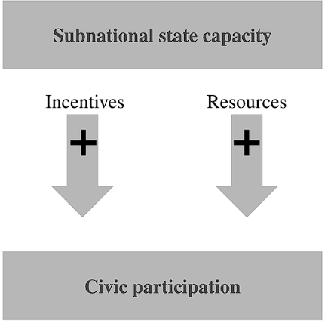
Figure 1. The positive impact of SSC on civic participation
This causal mechanism can act in the opposite direction. If the high SSC reduces the incentives for citizens to participate in society because citizens have a strong belief that the government can handle everything on its own, thereby reducing the incentives for independent participation in solving public problems. Citizens get used to being taken care of and stop feeling the need for active participation. This is the opposite of the classic learned helplessness effect, when people stop acting because they feel powerless. On the contrary, people stop acting because they are confident in the power of the subnational authorities. Decrease in civic participation is not necessarily a negative phenomenon. It can be a sign of stability and well-being of society. Resources can be formed for civic participation, but there are no incentives for citizens to participate, which will not lead to high rates of civic participation. If the SSC is high and the policy to improve the lives of the population is implemented effectively, it is possible to reduce civic participation.

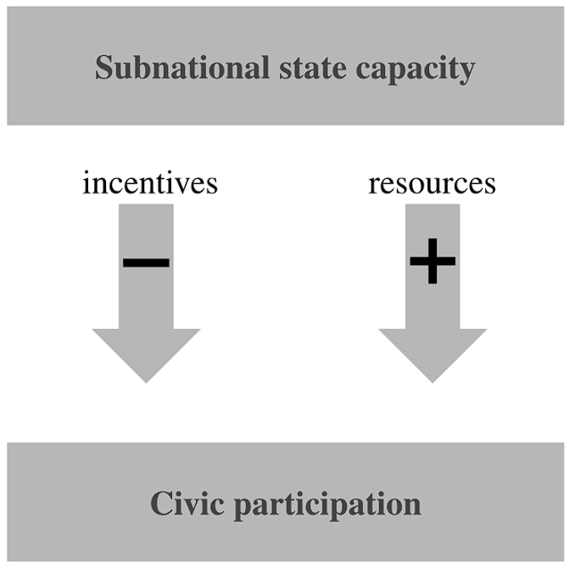
Figure 2. The negative impact of SSC on civic participation
Thus, analyzing possible mechanisms, I outline the Hypothesis 1a of this study: the higher SSC in the region, the higher level of civic participation is. Moreover, there is the alternative Hypothesis 1b: the higher SSC in the region, the lower level of civic participation is. To test the implications of the theory at the individual level, I test Hypothesis 2a: the higher the SSC in the region, the more actively people participate in various forms of civic participation. There is also Hypothesis 2b: the higher the SSC in a region, the less actively people participate in various forms of civic participation.

2. Methodology and data
This study is based on a quantitative analysis of data in a regional-temporal (panel) context. The aim is to identify the relationship between SSC level as an independent variable and the level of civic participation as a dependent variable in the Russian regions for the period 2014-2023. Panel data sources include official statistics from Rosstat (regional statistics) and the Ministry of Justice.
The choice of panel data is determined by the structure of the available information covering several subjects of the Russian Federation (cross-sectional component) over a number of years (time component). This format allows to simultaneously take into account both interregional differences and the dynamics of changes over time.

2.1 Methods and control variables
The empirical analysis uses models at the regional and individual levels to account for contextual factors and analyze the impact of general trends on individual behavior, which provides a completer and more reliable picture of the impact of SSC on civic participation. The methodological framework includes the construction of an integral SSC index, the use of panel regression models with Random and Fixed Effects, which allows control of the time-invariant characteristics of Russian regions. The inclusion of regional effects eliminates the bias caused by these constant factors, thereby providing a more accurate assessment of the impact of SSC dynamics on civic participation. For this study, the following variables were selected for regional effects:
- Gross Regional Product (GRP) per capita in rubles
This variable as random or fixed effects reflects the economic level of the region and does not imply a strict correlation with the main explanatory variables.
- Level of urbanization (percentage of urban population)
Urbanization was formed as a result of historical factors reflecting the long-term demographic and infrastructural features of the region, which can influence the forms and intensity of civic participation. At the same time, urbanization is considered as an external structural characteristic that weakly correlates with the main explanatory variables and does not change dramatically over time.

- Percentage of the retirement age population (percentage of the total population)
A high proportion of the retirement age population can have an impact on the level and nature of civic participation. This allows taking into account the long-term impact of the age structure of the population on civic participation, without confusing it with the influence of dynamic factors such as the SSC index.
To test the implications of the theory at the individual level, I use LCSR Regional Survey 2019, consisting of issues related to trust in the authorities and civic participation, and data on 14,000 respondents, indicating the region where each respondent lives. The survey data also contains individual-level socio-demographic variables such as gender, age, education, income. The dependent variable is the coded responses of respondents to a question about their participation in various civic activities. The independent variable is the SSC index I calculated, which I uploaded to each respondent. In this part of the analysis, I used a multilevel regression mixed-effects model, taking into account three variables as fixed effects from the previous part of the study, and age, gender, income and education level as the second level of variables.

2.2 Justification of Sample Selection and Temporal Scope
For comparability of data and to reduce the influence of institutional and socio-cultural factors, the sample of subjects of the Russian Federation was limited. In case selection, the territories of the North Caucasus, Crimea, other ethnic republics, federal cities, as well as territories involved in the conflict with Ukraine are excluded from the sample. Data from 60 subjects of the Russian Federation for 2014-2023 were used for the analysis. This allows focusing on a more homogeneous set of regions in terms of administrative and institutional structure, which enhances the internal validity of the study and increases the interpretability of the regression analysis results.
The period from 2014 to 2023 was chosen for analysis because it covers key stages of Russia's institutional and socio-economic transformations, including the strengthening and weakening of the role of regions and the transformation of forms of civic participation. In addition, since 2014, official statistics on most indicators have become more systematic and comparable between the subjects of the Russian Federation. However, data on civic participation in Russia is limited. The analysis includes information on the number of volunteers only for the period 2018-2023, as early information is not available in open sources and is presented fragmentally. And the survey data contains information only about 2019.

2.3 Operationalisation of Subnational state capacity
Since I conceptualize SSC, an independent research variable, through the result of the bureaucracy's activities, that is, their functional ability to achieve goals, I will focus on the results of the bureaucratic apparatus activities to operationalize SSC. Within the framework of this study, SSC is operationalized through a set of infrastructural and institutional indicators reflecting the ability of regional authorities to ensure citizens' access to basic public goods and services. To identify specific areas of activity for bureaucrats, I turned to the decree on Russia's national goals until 2030. I have highlighted the following main areas that demonstrate the effectiveness of the work of regional bureaucrats: а) preserving the population, improving people's health and well-being, and supporting families; b) a comfortable and safe living environment; c) technological leadership; d) digital transformation of state and municipal administration, economy and social sphere. Therefore, four indicators were selected to build the SSC integral index:
- Number of hospital beds (per 10,000 population)
This indicator reflects the level of provision of the healthcare system with inpatient infrastructure and demonstrates the ability of regional administrations to maintain access to medical services for the population, as well as to effectively plan resources.
- Provision of preschool-age children with places in preschool educational institutions (per 1,000 children of the appropriate age)
The indicator characterizes the effectiveness of bureaucrats' actions within the framework of the region's social policy in the field of preschool education and the accessibility of kindergartens as one of the basic elements of social infrastructure.
- The share of the total area of the housing stock equipped with a drainage system (sewerage) in the total area of residential premises
The indicator reflects the level of development of the housing and communal infrastructure, for which the regional bureaucratic system is responsible, and the ability of bureaucrats to provide basic sanitary and hygienic living conditions.
- Number of personal computers used for educational purposes in state and municipal educational institutions (per 100 students)
The indicator demonstrates the level of technological equipment of the education system and the ability of regional bureaucrats to implement the tasks of digitalization and the formation of an information society.
Each of these indicators was standardized through min-max normalization, where x is the value of the indicator, x' is the normalized value (from 0 to 1).
x'=$\frac{x-min(x)}{max(x)-min(x)}$
After that, I aggregated these values into the SSC index, reflecting the overall level of institutional and infrastructural viability of regional administrations, where hosp_beds is the number of hospital beds, kindergartens is the provision of preschool–age children with places in preschool educational institutions, sewage is the proportion of the total area of the housing stock equipped with a sewage system, in the total area of residential premises, and computer – the number of personal computers used for educational purposes and municipal educational institutions in the region.
$SSC_index$ = $\frac{hosp_beds' + kindergartens' + sewage'+ computer' }{4}$

2.4 Operationalisation of civic participation
In the framework of this study, I consider civic participation as a set of forms of citizen involvement in socially significant activities, mediated either through participation in NGOs, or through volunteerism. The following indicators were used in measuring civic participation:
- Institutionalized participation through the number of registered NGOs per 1000 population.
NGO registration reflects the level of self-organization of citizens and their desire to participate in solving socially significant tasks outside the framework of political institutions. In the Russian context, NGOs play an important role as intermediaries between society and the state, contributing to the implementation of social initiatives, the protection of the rights of various groups, and the development of civic participation at the local level.
- Volunteerism is measured using the average number of volunteers (per 1000 population, the value of the indicator for the year)
Volunteering reflects the willingness of citizens to engage in socially significant tasks on a voluntary basis. The use of this form of civic participation makes it possible to quantify the level of public involvement in such initiatives and, accordingly, serves as a representative measure of civic participation at the regional level.
In addition, I divided found data on the number of registered NGOs and volunteers in the region by the number of populations in the region in order to avoid incorrect interpretations.
For the second part of the empirical research, the survey data is used. Civic participation is captured by question 26th, where different forms of civic participation are named, and the respondent answers whether they have participated in them (1) or did not participate (0) during the last 2 years. This 26th question is used as a dependent variable that determines civic participation in the following forms:
- clean-up day, landscaping of a district or city (cleaning day);
- signing petitions, collective letters, appeals, including on the Internet;
- protest actions, pickets, demonstrations;
- blogs, on forums, in order to attract people's attention;
- material donations to charity events;
- volunteering, including providing their professional services to solve public problems. problems for charity events;
- other forms of voluntary community work to make life better around a person.

Empirical analysis
The use of panel data makes it possible to take into account the individual heterogeneity of the research objects and monitor the unobservable factors affecting civic participation in the regions. To do this, I built models with fixed (FE) and random (RE) effects. To understand which model to use to build regression on two dependent variables (vol_per_1000, ngo_per_1000) I did the Hausman test (Appendix1):
- For vol_per_1000 (volunteering): p-value = 1.783e-15 is less than 0.05 → Choose a fixed-effects (FE) model. This indicates that differences between regions are correlated with explanatory variables, making the random-effects (RE) model inconsistent.
- For ngo_per_1000 (number of NGOs): p-value = 6.066e-16 is less than 0.05 → Choose a fixed-effects (FE) model. The RE-model is untenable because there is a correlation between individual effects of regions and regressors. FE can fix this issue.

3.1 The impact of SSC on civic participation at the regional level
I have built panel regression models that demonstrate the impact of SSC on the number of registered NGOs and volunteers in the region, taking into account the fixed effects.
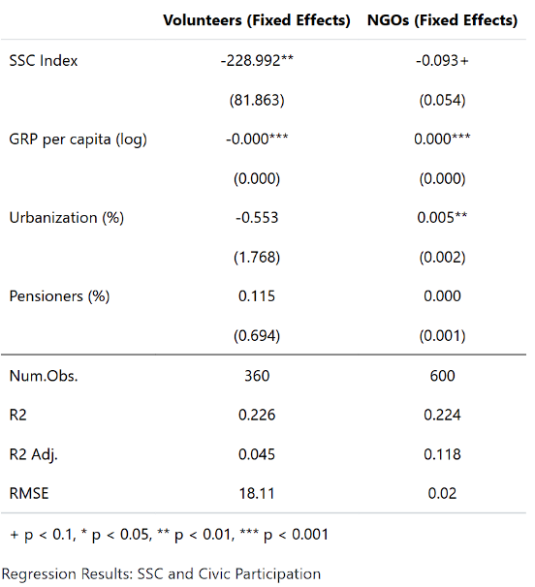
Table 1. The impact of SSC on the number of volunteers per 1,000 population and number of registered NGOs per 1,000 population
As a result, for the model of NGOs (Appendix 3), hypothesis 1b was confirmed: SSC has a low significant negative effect on the number of registered NGOs. Increasing per one unit of the index SSC is associated with a decrease of 0.093 units of the DV – number of registered NGOs – ceteris paribus. Control variable GRP and urbanization have positive significant effects.
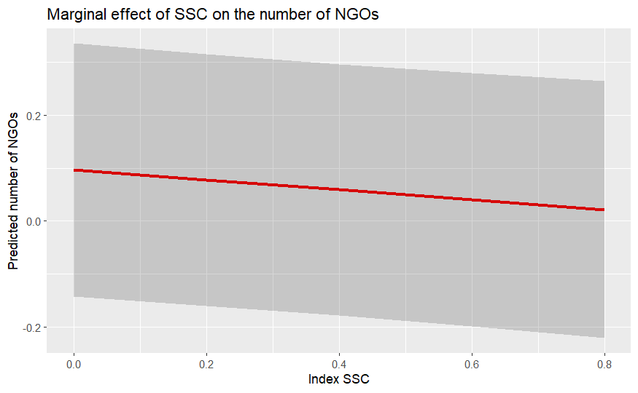
Figure 3. The marginal effect of SSC on the number of NGOs
For the model with the number of volunteers (Appendix 2), hypothesis 1b was again confirmed: SSC has a significant negative effect on the number of volunteers. Increasing per one unit of the index SSC is associated with a decrease of 229 units of the DV – number of volunteers – ceteris paribus. The results of the influence of control variables on the number of volunteers are insignificant except GRP that is of statistical significance and has a positive impact on the number of volunteers, but the effect is minimal (the coefficient is close to zero).
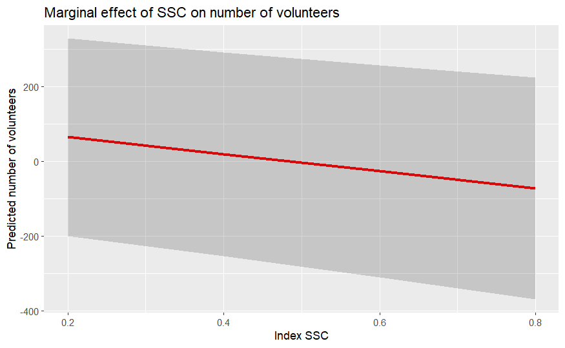
Figure 4. The marginal effect of SSC on the number of volunteers
I checked the impact of not only the SSC index, but also each individual component, taking into account the fixed effects. The number of hospital beds, kindergartens, sewerage facilities, and computer facilities of educational institutions confirmed the negative impact on the number of NGOs and volunteers.

3.2 The impact of the SSC on individual participation in various forms of civic participation
I conducted a multi-level regression to answer the question of impact of SSC on the forms of civic participation of citizens based on survey data. It is essential to note that all scales of respondents’ responses (except for age variable, which contains the age of the respondents) are encoded as dummy variables. For questions about participation of citizens in forms of civic participation: 0 – did not participate, 1 – participated. For questions about social trust and satisfaction of regional authorities: 0 – do not trust people and are not satisfied with the work of governors and mayors, 1 – trust people and are satisfied with the work of governors and mayors respectively. For individual variables: gender: 0 – men, 1 – women; education: 0 – there is no higher education, 1 – there is higher education; money: 0 – less than 25,001 - 35,000 rubles inclusive, 1 – more than 25,001 - 35,000 rubles not inclusive.
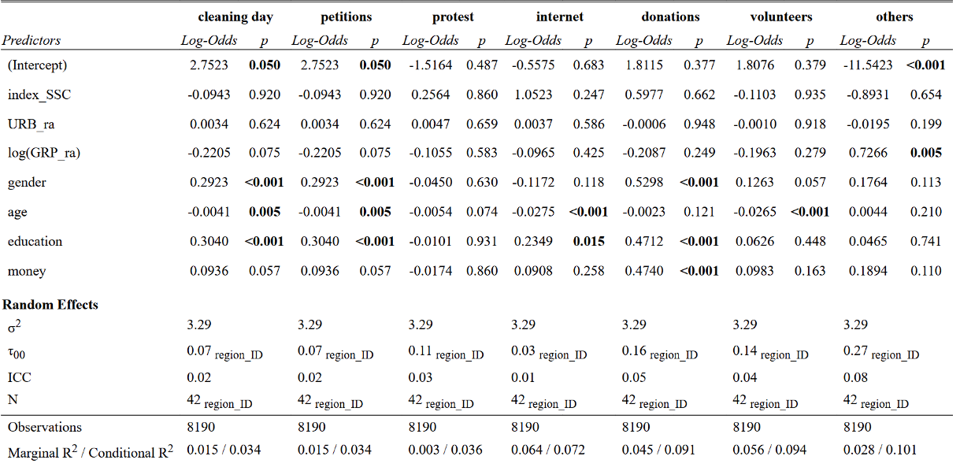
Table 2. The impact of SSC on the forms of manifestations of civic participation
Based on the results of the binary multilevel models via the glmer function, it became obvious that it cannot be speculated on the existence of the impact of SSC on the presented forms of civic participation of respondents. Moreover, regional effects (urbanization and GRP) are insignificant in this model: only GRP is significant for other forms of civic participation (p-value = 0.005). The share of pensioners in these models is not important for the interpretation because it does not affect individual decisions of people.
However, at the individual level, it was possible to trace the relationship: Age significantly affects participation in cleaning days, petitions, internet activities and volunteering (p-value = <0.005). Older people are more likely to participate in these activities. Education also has a significant effect on dependent variables – the higher the education, the higher the participation in cleaning days, petitions, internet activities and donations. The level of well-being is also significant for one dependent variable. According to the results, wealthier people are more likely to participate in donations. Gender is significant for participation in cleaning days, petitions and donations. Women participate more actively in these forms.
In the theoretical framework, I pointed out the importance of social and political trust for the relationship between SSC and civic participation. The survey contains questions about citizens' trust in society and the subnational state and satisfaction with the work of governors and mayors. I used them as dependent variables to identify the relationship between SSC and social and political trust which in turn influence civic participation.
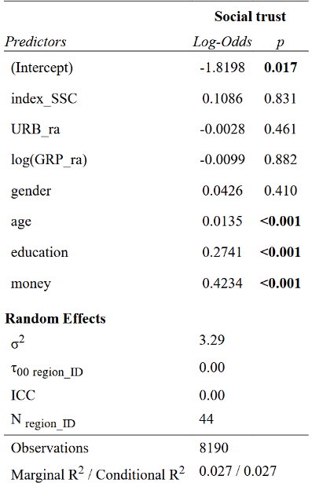
Table 3. The impact of SSC on social trust
As for the results, it became obvious that SSC is insignificant for the influence on social trust of respondents. Only individual characteristics (age, education and money) are significant for social trust of respondents: older, more educational and richer people tend to trust other people more. Thus, a relationship “SSC → social trust → civic participation” does not work. However, I decided to conduct an analysis to identify the relationship between social trust and civic participation in order to understand whether social trust can independently influence civic participation.
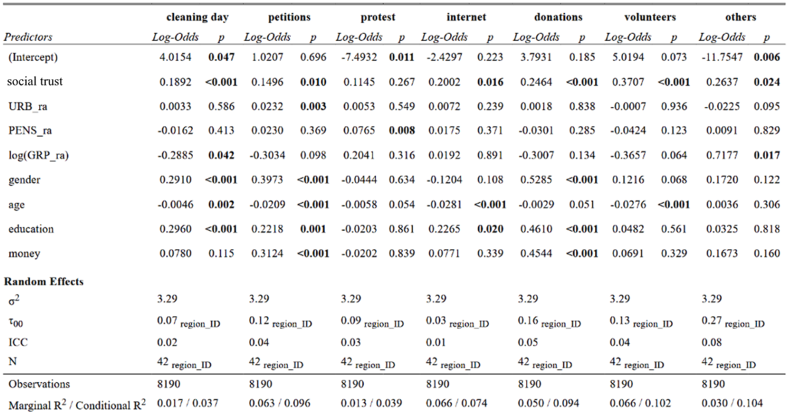
Table 4. The impact of social trust on the forms of manifestations of civic participation
The results demonstrate that social trust is significant for almost all forms, which indicates a statistically positively significant effect for cleaning day, petitions, internet activities, donations, volunteers and other forms of civic participation. The results demonstrate that the more people trust other people, the more they participate in civic activities which is consistent with the theoretical expectations and previous research.
Moreover, I decided to test the impact of SSC on the following mechanism: SSC affects satisfaction and trust in regional authorities, which in turn will affect civic participation.
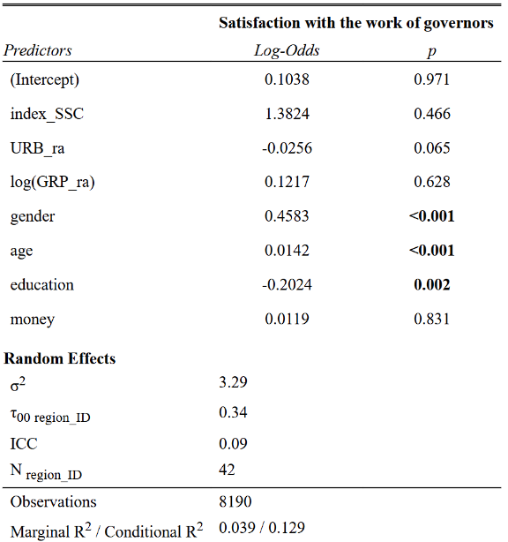
Table 5. The impact of SSC on satisfaction with the work of governors
As for the results, it is observed that SSC is insignificant for the influence on satisfaction of respondents with the work of governors. Only individual characteristics (gender, age and education are significant for satisfaction of governors: women, older and more educational people tend to be satisfied more with the work of governors.
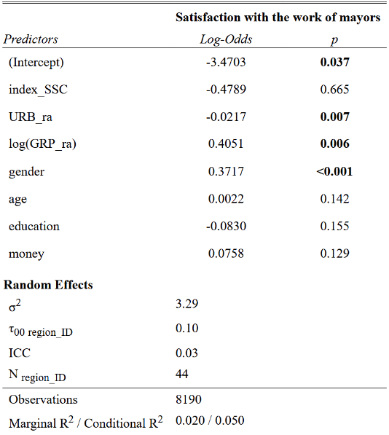
Table 6. The impact of SSC on satisfaction with the work of mayors
In addition, gender is also significant at the individual level of the influence of SSC on the satisfaction with the work of mayors. Thus, a relationship like “SSC → satisfaction with governors and mayors → civic participation" does not work. However, I decided to conduct an analysis to identify the relationship between satisfaction and civic participation in order to understand whether satisfaction with the work of regional authorities can independently influence civic participation.
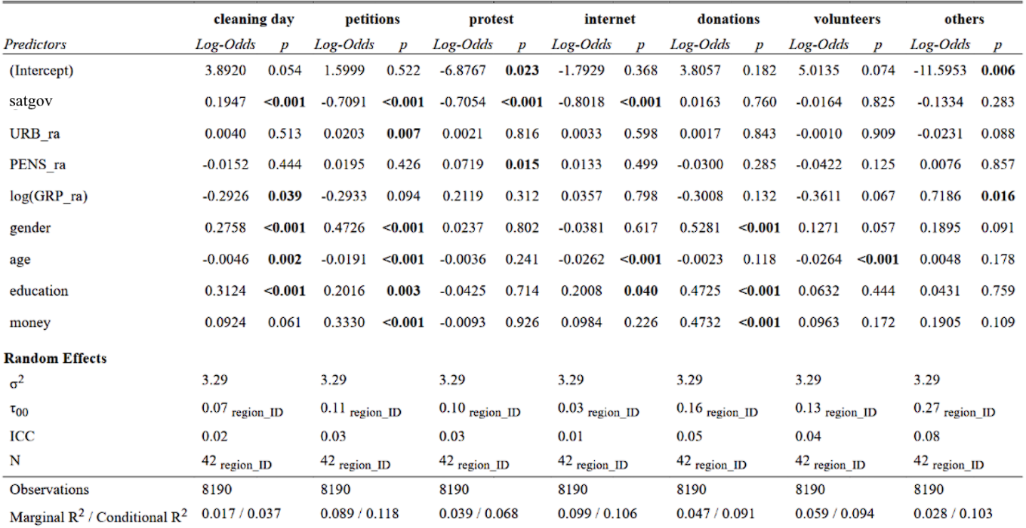Table 7. The impact of satisfaction of governors on the manifestations of civic participation
I also analyzed the impact of satisfaction with regional measures on participation in various forms of civic activity.
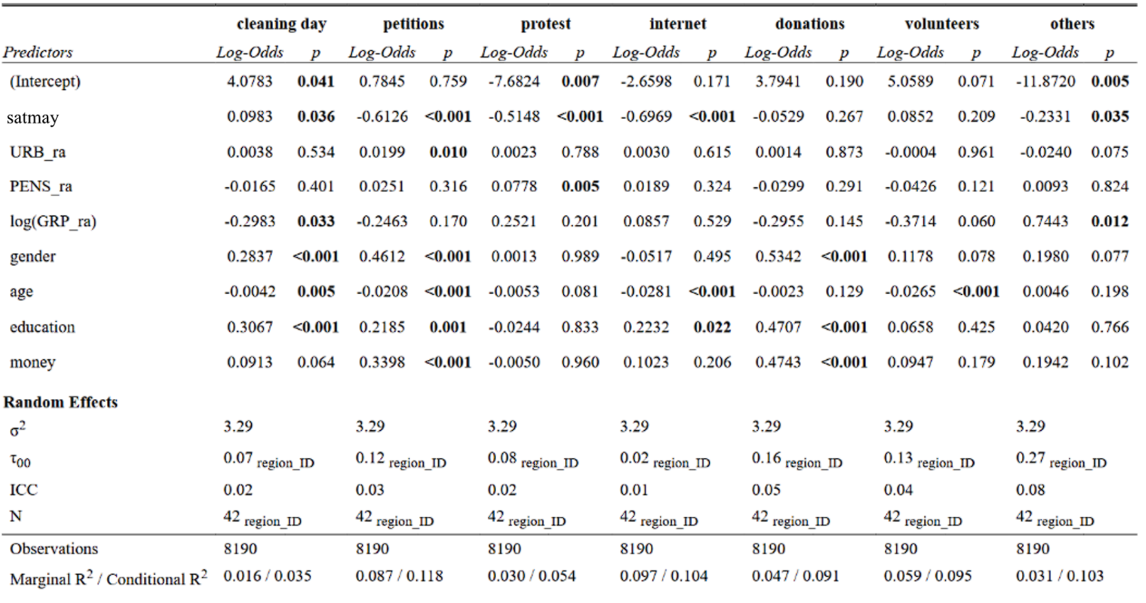
Table 8. The impact of satisfaction of mayors on the manifestations of civic participation
Satisfaction with the performance of regional authorities — governors and mayors — shows a statistically significant relationship with following forms of civic participation: cleaning days, protests, petitions, internet activities and other forms of civic participation (only for satisfaction with mayors). Interestingly, this relationship is negative for activities such as signing petitions, participating in protests, and engaging in internet-based civic actions. Individuals who are more satisfied with regional authorities tend to be less involved in these critical or mobilizational forms of civic participation. However, satisfaction with authorities is positively associated with participation in local collective actions such as cleaning days. This form of civic participation often aligns with state-promoted initiatives and may reflect a cooperative, rather than adversarial, relationship with the authorities. Hence there is a link between satisfaction with the work of regional authorities and civic participation in the mechanism of influence, but SSC has no influence.
Finally, the following results were received:
- The SSC negatively affects the number of registered NGOs in the region. The higher SSC in a region, the fewer NGOs are registered in that region. This corresponds to hypothesis 1b: the higher the SSC, the lower the civic participation in the region.
- The SSC negatively affects the number of volunteers in the region. The higher SSC, the fewer volunteers there are in the region. This corresponds to hypothesis 1b: the higher the SSC, the lower the civic participation in the region.
- No statistically significant relationship was found between the SSC and an individual's desire to participate in various forms of civic participation. At the same time, individual civic participation is influenced by individual characteristics such as gender, age, income and education.
- The relationship between social trust and the manifestation of civic participation in various forms turned out to be as follows: the more people trust other people, the more actively they participate in civic activity.
- Satisfaction with the activities of regional authorities and political trust (the governor and the mayor) influences participation in civic participation of various forms. The more people are satisfied with the work of the regional authorities, the less active the civic participation is.
Thus, the first part of the study fully confirmed the hypothesis 1b about the negative impact of SSC on civic participation at the regional level. However, the second part of the study did not show the impact of SSC on civic participation at the individual level.

Discussion
Turning to the discussion of the results, it is worth noting that the results are ambiguous. It can be concluded that SSC have a negative impact on civic participation at the regional level, measured by the number of registrations of NGOs and volunteers (according to panel regressions) during 2014-2023 in the Russian regions, which confirms hypothesis 1b. Thus, the logic is confirmed that in Russian regions with a higher level of SSC, citizens demonstrated less involvement in civic activity in 2014-2023, since they do not feel the need for it — the main functions and initiatives are effectively implemented by the regional authorities. The theory provides the idea that the state can rely on NGOs to develop the effectiveness of providing services to the public. However, regions with high SSC do not need outside assistance from civil society organizations. Therefore, for the regional authorities, the development of civil society by increasing the number of NGOs and volunteers is not a priority and they are not interested in it.
With regard to civic participation at the individual level, although SSC has not shown significance in influencing participation of respondents in various forms of civic activity, significant links have been found between the alleged mechanisms of incentives and resources influence: satisfaction with the work of regional authorities (political trust) and social trust on various forms of civic participation. The first element of the mechanism is understood as reflecting a reduced need for civic participation, which reduces people's incentives to participate. The second element is perceived as a social resource, because with greater trust in society, it is easier for people to unite and organize civic participation to improve everyone's life.
Satisfaction with the work of regional authorities has a negative impact on participation, while social trust has a positive impact. It can be assumed that the SSC probably has an indirect effect: not the SSC itself, but the associated social conditions — resources and incentives — turn out to be significant predictors of civic participation. However, SSC has no effect on either the level of trust or satisfaction, and the assumed model of indirect influence cannot be relevant.
It is important to note the following findings: social trust positively and satisfaction with power negatively significantly influence civic participation. Thus, it can be thought that resources and incentives, regardless of the SSC level, play an important role in shaping civic participation. But the mechanism “SSC → incentives + resources → civic participation” was not confirmed, since SSC does not affect either incentives and resources or civic participation at the individual level.

Indeed, at the individual level, SSC has no significant impact on incentives and resources for civic participation at the research of individual level. However, it was found out that with increasing satisfaction with government, citizens are demotivated to participate in civic activities. And the more they trust each other within society, the more resources and opportunities are formed for civic participation, which increases it (Appendix 7). However, the formation of resources does not mean that citizens decide to use them if there are no incentives.
Thus, the direct negative impact of the SSC on civic participation is limited only to the regional level. This study suggests the need to operationalize the SSC using other indicators. To fully research the impact of the region's governance effectiveness on civic participation, it is necessary to consider SSC as a concept from different angles – for example, to pay attention to the operationalization of SSC through economic and managerial indicators, as well as to focus on the process of policy implementation, not just on the results. This indicates the need for further research on the various factors and mechanisms of their influence on civic participation separately at the individual and regional levels.

Conclusion
I managed to achieve the goals and complete the objectives set at the beginning of the study. This research conducted an extensive literature review. Various approaches of researchers to conceptualizing state capacity and civic participation were considered. Due to the in-depth analysis of the existing literature, it was possible to identify a research gap, which consists in insufficient attention to the study of the impact of SSC on civic participation, firstly, in states with weak democratic institutions, and secondly, to the study of this relationship at the regional level.
In the theoretical part of the study, the concepts of SSC and civic participation were considered separately. It also describes the path of evolution and the context of the development of SSC and civic participation in Russia through 2014-2023, which helped to form a complete picture for understanding the dynamics of the interrelation of concepts. Moreover, I considered the mechanisms of possible interaction between SSC and civic participation through the formation of incentives and resources. Incentives are conceptualized through political trust theory and satisfaction with the work of regional authorities. As the results demonstrated, I made the right decision – to identify not only one possible scenario of the SSC's impact on civic participation. The first mechanism of influence would reflect the positive impact of SSC on civic participation. Developed governance within the region, providing citizens with a higher standard of living through effective policies, encourages citizens to participate and be interested in improving their living conditions even more. They understand that authorities are also interested in developing the well-being of the population, and therefore see the point in civic participation. On the other hand, the second scenario is the opposite. If the authorities cope with their tasks and ensure the fulfillment of the needs of the population, citizens are demotivated, as responsibility is shifted to the authorities. In this case, it makes no sense for citizens to unite and do something on their own for the development of society. Resources, in turn, are conceptualized through social trust theory. Here, the mechanism of the theory is explained as follows: the more developed the ability of the authorities to ensure the implementation of effective policies in the public interest, the more people tend to trust other people.
The study succeeded in answering the research question posed: “How does SSC influence civic participation in the regions of Russia in 2014-2023?”. Using panel data on 60 regions for 2014-2023 and respondents’ responses on their participation in civic activity in 2019 at the individual level, ambiguous findings were obtained.
The first part of the empirical research approved Hypothesis 1b: the higher SSC in the region, the lower level of civic participation is. However, this hypothesis has been confirmed at the regional level of the research of civic participation. Therefore, at the regional level, SSC has a negative impact on civic participation. The more effective bureaucrats implement policies and ensure the fulfillment of the needs of the population, the lower the activity in formal forms of participation at the regional level (the number of NGOs and volunteers). This relationship can be explained by the following mechanism: effective regional authorities reduce the incentives of citizens for civic participation, since the main tasks of improving life are successfully implemented by the authorities.
This study has findings on the impact of SSC on civic participation at the individual level. It turned out that at the level of individual citizens, the macroeconomic indicators of SSC do not have a significant impact on participation in informal activities such as petitions, cleaning days, online activities, informal volunteering, donations, etc. However, individual factors (age, education, income, and gender) demonstrated a significant impact on participation in various forms of civic participation. For example, women and people with higher education are more likely to participate in various forms of civic participation. Thus, these findings can be useful in further research of civic participation in Russia on an individual level.
Moreover, the study obtained findings in testing the mechanism of SSC influence on civic participation through incentives and resources. Social trust plays the role of resources for people within the framework of civic participation. The regression results showed that social trust positively influences participation in various forms of civic activity: the higher the trust between people, the more active their civic participation. Satisfaction with the work of the regional authorities acted as incentives for participation in civic activities. The results were notable: greater satisfaction with the work of regional authorities led to increased involvement only in loyal forms of activity (cleaning days), while there was a negative impact on participation in other forms of civic participation aimed at active actions that could become dangerous for regional authorities (petitions, protests and online civic activity). Thus, in general, the study partially confirmed the hypothesis of a negative effect of SSC on civic participation (however, it is important to take into account the limitations of the study listed below). In Russia, the high SSC of the regions suppresses formal civic participation, but does not exclude informal practices. That is reflected by the model of participatory authoritarianism, where the Russian authorities allow limited activity in exchange for loyalty – this assumption opens up space for future research.
This paper can be considered as the beginning for future research not only in Russia, but also in other countries with a low level of political competition. I suggest that it is necessary to delve into the consideration of unique cases within the framework of comparative political science in order to identify patterns and describe in more detail the interaction between SSC and civic participation. I would also note that due to the specifics of data availability in Russia, this study was limited in time coverage in terms of the number of volunteers in the region (2018-2023), and the 2019 survey data did not allow tracking the dynamics of changes over time. It also makes sense to consider in more detail the individual level of citizens' involvement in civic participation through qualitative methods (for instance, large-scale interviews with activists). As this study measured SSC through macro indicators, it might not reflect people's individual motivation, and it was probably this limitation that caused the lack of correlation between SSC and participation of the respondents in the various forms of civic activity.

Bibliography
Addison, Helen. "Is Administrative Capacity a Useful Concept? Review of the Application , Meaning and Observation of Administrative Capacity in Political Science Literature." (2010). https://personal.lse.ac.uk/addisonh/Papers/AC_Concept.pdf.
Almakaeva, A., Andreenkova, A., Klimova, A., Soboleva, N., & Ponarin, E. (2019). Values in the Russian Regions, LCSR Regional Survey. Moscow: Higher School of Economics.
Back, Hanna and Axel Hadenius. "Democracy and State Capacity: Exploring a J Shaped Relationship". Governance: An International Journal of Policy, Administration and Institutions, 21(1) (2008): 1-24.
Bergson, Abram. Review of Review of An Economic Theory of Democracy, by Anthony Downs. The American Economic Review 48, no. 3 (1958): 437–40.
Benevolenski, Vladimir B., and Stefan Toepler. “Modernising Social Service Delivery in Russia: Evolving Government Support for Non-Profit Organisations.” Development in Practice, January 2, 2017. https://www.tandfonline.com/doi/abs/10.1080/09614524.2017.1259392.
Bunce, Valerie. "Comparative Democratization. Big and Bounded Generalizations". Comparative Political Studies, Vol. 33 No. 6/7 (2000): 703-734.
Campbell, Jesse W. "Public Participation and Trust in Government: Results From a Vignette Experiment." Journal of Policy Studies 38, no. 2 (2023): 23-31. https://doi.org/10.52372/jps38203.
Centeno, Miguel Angel, Atul Kohli, Deborah J. Yashar, and Dinsha Mistree. "Unpacking States in the Developing World: Capacity, Performance, and Politics." Chapter. In States in the Developing World, edited by Miguel A. Centeno, Atul Kohli, and Deborah J. Yashar, 1-32. Cambridge: Cambridge University Press, 2017.
Cnaan, Ram A., and Sohyun Park. “The Multifaceted Nature of Civic Participation: A Literature Review,” September 30, 2016. https://doi.org/10.1163/24054933-12340001.
Checkoway and Adriana Aldana. "Four forms of youth civic engagement for diverse democracy." Children and Youth Services Review, 35 (2013): 1894-1899. https://doi.org/10.1016/J.CHILDYOUTH.2013.09.005.
Cuthill, Michael, and John Fien. “Capacity Building: Facilitating Citizen Participation in Local Governance.” Australian Journal of Public Administration 64, no. 4 (2005): 63–80. https://doi.org/10.1111/j.1467-8500.2005.00465a.x.
"Democracy Index 2017." Accessed February 17, 2025. https://www.eiu.com/public/topical_report.aspx?campaignid=DemocracyIndex2017.
Dennon, A. R. Review of Review of Political Order in Changing Societies, by Samuel P. Huntington. Science & Society 34, no. 2 (1970): 251–53.
Dincecco, Mark, and Gabriel Katz. “State Capacity and Long-Run Performance.” MPRA Paper, April 23, 2012. https://mpra.ub.uni-muenchen.de/38299/.
Duvanova, Dinissa. “Bureaucratic Discretion and State Capacity in Russian Regions.” In Thieves, Opportunists, and Autocrats: Building Regulatory States in Russia and Kazakhstan, edited by Dinissa Duvanova, 0. Oxford University Press, 2023. https://doi.org/10.1093/oso/9780197697764.003.0005.
Ekman, Joakim and Amnå, Erik. "Political participation and civic engagement: Towards a new typology" Human Affairs 22, no. 3 (2012): 283-300. https://doi.org/10.2478/s13374-012-0024-1
Evans, P. and Rauch, J. E. . Bureaucracy and growth: A cross-national analysis of the effects of "Weberian" state structures on economic growth. American Sociological Review, 64(5) (1999): 748-765.
Evans, P. B. Embedded Autonomy. Princeton University Press., 1995.
Fearon, J. D. and Laitin, D. D. Ethnicity, insurgency, and civil war. American Political Science Review, 97(01) (2003):75–90.
Fearon, J. D. Primary commodity exports and civil war. Journal of Conflict Resolution, 49(4) (2005):483–507.
Finch, W. Holmes, Jocelyn E. Bolin, and Ken Kelley. Multilevel Modeling Using R. 2nd ed. New York: Chapman and Hall/CRC, 2019. https://doi.org/10.1201/9781351062268.
Fjelde, Hanne and Indra De Soysa. "Coercion, Co-optation, or Cooperation?: State Capacity and the Risk of Civil War, 1961-2004". Conflict Management and Peace Science. 26(1) (2009): 5-25.
Fukuyama, Francis. State-building: Governance and World Order in the 21st Century. Ithaca, NY: Cornell University Press, 2004.
Gargan, John J. "Consideration of Local Government Capacity." Public Administration Review 41 (6) (1981):649-58.
Gelman, Vladimir. “The Dynamics of Subnational Authoritarianism: (Russia in Comparative Perspective).” Russian Politics & Law 48, no. 2 (March 1, 2010): 7–26. https://doi.org/10.2753/RUP1061-1940480201.
Giraudy, Agustina. "Conceptualizing State Strength: Moving Beyond Strong and Weak States". Revista de Ciencia Política. (2012) 32(3): 599-611.
Goggin, Malcolm, Ann Bowman, James Leste, and Laurence O'Toole Jr. 1990. Implementation Theory and Practice: Toward a Third Generation. New York: Harper Collins.
Häggblom, Erasmus. “The Trade-Off Between Political Trust and Political Participation.” Political Studies Review, December 21, 2024, 14789299241304611. https://doi.org/10.1177/14789299241304611.
Hall, Peter. "Creative Cities and Economic Development." Urban Studies 37, no. 4 (April 1, 2000): 639-49. https://doi.org/10.1080/00420980050003946.
Hamm, Patrick, and Lawrence King. “Post-Manichean Economics: Foreign Investment, State Capacity and Economic Development in Transition Economies.” Working Papers, Working Papers, 2010. https://ideas.repec.org//p/uma/periwp/wp227.html.
Hanson J.K. "State Capacity and the Resilience of Electoral Authoritarianism: Conceptualizing and Measuring the Institutional Underpinnings of Autocratic Power" // International Political Science Review, vol. 39, no. 1 (2018): 17-32.
Haque, M. Shamsul, M. Ramesh, Jose A. Puppim de Oliveira, and Alexandre de Avila Gomide. "Building Administrative Capacity for Development: Limits and Prospects." International Review of Administrative Sciences 87, no. 2 (June 1, 2021): 211-19. https://doi.org/10.1177/00208523211002605.
Hardin, Russell. 1982. Collective Action. Baltimoreand London: Johns Hopkins University Press.
Huber Evelyne, D. Rueschemeyer and J. D. Stephens. "The Impact of Economic Development on Democracy", Journal of Economic Perspectives, 7, (1993) 71-85.
Huntington, S. (1968). Political order in changing societies. New Haven.
Izvestiia. "Rossiia sosredotachivatesia - vyzovy, na kotorye my dolzhny otvetit' | Stat'i | Izvestiia." Accessed April 4, 2025. https://iz.ru/news/511884. 2025.
J. V. Deth, J. R. Montero and Anders Westholm. "Citizenship and involvement in European Democracies : A Comparative Analysis." (2007). https://doi.org/10.4324/9780203965757.
Jaros K. "Rethinking Subnational Government Capacity in China" // Journal of Chinese Governance, vol. 1, no. 4 (2016): 633-653.
"Jefferson on Politics & Government: Good Government." Accessed May 15, 2025. https://www.famguardian.org/Subjects/Politics/ThomasJefferson/jeff0650.htm.
Kaufman, Daniel, Aart Kraay, Pablo Zoido. Governance Matters. World Bank Policy Research Working Paper No. 2196. (1994)
Konsul'tantPlus. "Federal'nyi zakon 'Ob osnovakh obshehestvennogo kontrolia v Rossiiskoi Federatsii' ot 21.07.2014 N 212-FZ (poslednia radakisia)." Accessed April 4, 2025. https://www.consultant.ru/document/cons_doc_LAW_165809/. 2025.
"Konsul'tantPlys. 'UK RF Stat'ia 280.3. Publichnye deistviia, napravlennye na diskreditatsiiu ispol'zovanlia Vooruzhennykh Sil Rossiiskoi Federatsii v tseliakh zashchity interesov Rossiiskoi Federatsii i ee grazhdan, podderzhanlia mezhdunarodnogo mira i bezopasnosti, ispolneniia..." Accessed April 4, 2025. https://www.consultant.ru/document/cons_doc_LAW_10699/laa9268c7d3bd57bcbd46a3016641c5af64b9c87/. 2025.
Kurtz, Marcus J. and Andrew Schrank. "Capturing State Strength: Experimental and Economic Approaches". Revista de Ciencia Política. 32(3) (2012): 613-621.
Lee, Sangwon, Liu ,Wenlin, and Seungahn and Nah. “Advancing Communication Infrastructure Theory: The Moderating Roles of Citizen Journalism Practice and Political Trust on Online Civic Participation.” Mass Communication and Society 26, no. 5 (September 3, 2023): 827–51. https://doi.org/10.1080/15205436.2022.2093750.
Levi, Margaret, and Laura Stoker. “Political Trust and Trustworthiness.” Annual Review of Political Science 3, no. Volume 3, 2000 (June 1, 2000): 475–507. https://doi.org/10.1146/annurev.polisci.3.1.475.
Lindvall, Johannes, and Jan Teorell. “State Capacity as Power: A Conceptual Framework.” State Capacity as Power: A Conceptual Framework, STANCE Working Paper Series, May 2016.
Linz, Juan J., and Alfred Stepan. Problems of Democratic Transition and Consolidation. Johns Hopkins University Press, 1996. https://doi.org/10.56021/9780801851575.
Linz, J. “Totalitarian and Authoritarian Regimes.” Boulder, CA: Lynne Rienner Publishers Ltd, 2000.
M. A. Khan, "Civic Engagement in Policy Development," in The World Public Sector Report 2008: People Matter--Civic Engagement in Public Governance (New York: United Nations Department of Economic and Social Affairs, 2008), 50-74.
M. Barrett and I. brunton-smith. "Political and Civic Engagement and Participation: Towards an Integrative Perspective." Journal of Civil Society, 10 (2014): 28 - 5. https://doi.org/10.1080/17448689.2013.871911.
Malafaia, Carla, Eeva Luhtakallio, Isabel Menezes, and Tiago Neves. “Being Civic While Disavowing Politics: An Ethnography of a Youth NGO in Portugal.” Current Sociology 66, no. 5 (September 1, 2018): 769–87. https://doi.org/10.1177/0011392117704243.
Mann, Michael. The Sources of Social Power: Volume 1: A History of Power from the Beginning to AD 1760. Vol. 1. Cambridge: Cambridge University Press, 1986. https://doi.org/10.1017/CBO9780511570896.
May, Peter J. "Policy Design and Implementation." In Handbook of Public Administration, ed. B. G. Peters and J. Pierre. London: Sage Publications, 2003.
McBride, Amanda. "Civic Engagement, Older Adults, and Inclusion." , 30 (2006): 66.
McBride, A., M. Sherraden and Suzanne Pritzker. "Civic Engagement Among Low-Income and Low-Wealth Families: In Their Words." Family Relations, 55 (2006): 152-162. https://doi.org/10.1111/J.1741-3729.2006.00366.X.
Mercer, Claire. "NGOs, Civil Society and Democratization: A Critical Review of the Literature." Progress in Development Studies, January 1, 2002. https://doi.org/10.1191/1464993402ps027ra.
Mersianova, Irina Vladimirova. "Grazhdanskoe uchastie vo vremia pandemii COVID-19." Sotsiodigger 2, no. 3 (8) (2021): 16-26. https://cvberleninka.ru/article/n/grazhdanskoe-uchastie-vo-vremya-pandemii-covid-19. 2021.
Meng and E. Berezina. "The Role of Personality and Self-Motivation in Political (Dis)Engagement." Makara Hubs-Asia, 24 (2020): 87. https://doi.org/10.7454/hubs.asia.2070220.
The Ministry of Justice of the Russian Federation. "Register of non-governmental organizations" Accessed May 15, 2025. https://minjust.gov.ru/ru/pages/reestr-nekommercheskih-organizacji/.
Moon, Bruce E. and William J. Dixon."Politics, the State, and Basic Human Needs: Cross-NationalStudy." American Journal of Political Science. 29(4) (1985): 661-94.
Moses, J. C. Putin and Russian Subnational Politics in 2014. Demokratizatsiya: The Journal of Post-Soviet Democratization, 23(2), (2015): 181-203. https://www.questia.com/library/journal/1P3-3759949571/putin-and-russian-subnational-politics-in-2014.
Niedzwiecki, Sara, and Jennifer Pribble. “Social Policy and State Capacity from a Sub-National Perspective.” In The Oxford Handbook of Governance and Public Management for Social Policy, edited by Karen J. Baehler, 0. Oxford University Press, 2023. https://doi.org/10.1093/oxfordhb/9780190916329.013.60.
Noh, Y., Public Opinion and Women's Rights in Autocracies, Politics & Gender, pp. 1-5, March 16, 2023. DOI: 10.1017/s1743923x22000514.
O'Donnell, Guillermo. "On the state, democratization and some conceptual problems: A Latin American view with glances at some post-communist countries". World Development. 21(8) (1993): 1355-1369.
Omoto, Allen M., And Mark Snyder. "Considerations of Community: The Context and Process of Volunteerism." American Behavioral Scientist 45, no. 5 (January 1, 2002): 846-67. https://doi.org/10.1177/0002764202045005007.
OVD-Info. 'Eydzhizm i vozrastnaya diskriminatsiya v kontekste svobody sobraniy v Rossii.' Accessed April 18, 2025. https://reports.ovd.info/eydzhizm-i-vozrastnaya-diskriminatsiya-v-kontekste-svobody-sobraniy-v-rossii.
Owen, C. “Participatory Authoritarianism: From Bureaucratic Transformation to Civic Participation in Russia and China.” ResearchGate, 2024. https://doi.org/10.1017/S0260210520000248.
Owen, C., & Bindman, E. “Civic participation in a hybrid regime: Limited pluralism in policymaking and delivery in contemporary Russia. Government and Opposition”, 54(1) (2019). 98-120. https://doi.org/10.1017/GOV.2017.13.
Parry, Geraint, George Moyser, and Neil Day. Political Participation and Democracy in Britain. Cambridge: Cambridge University Press, 1992. https://doi.org/10.1017/CBO9780511558726.
Pod"iachev, K. V. "Osnovnye formy grazhdanskogo uchastiya v usloviyakh sovremennoy Rossii." Nauchnaya elektronnaya biblioteka Grazhdanskoe obshchestvo v Rossii, no. 2-3. Moscow, 2013.
Przeworski, Adam. Sustainable Democracy. Cambridge: Cambridge University Press, 1995. https://doi.org/10.1017/CBO9780511664205.
Putnam, Robert D., Robert Leonardi, and Raffaella Y. Nonetti. Making Democracy Work: Civic Traditions in Modern Italy. Princeton University Press, 1993. https://doi.org/10.2307/j.ctt7s8r7.
RBK. "VSHe soobshchila o roste glubinnoi grazhdanskoi aktivnosti rossiian." December 7, 2020. https://www.rbc.ru/rbcfreenews/Sfcec52b9a794796ff11ca6. 2020.
"Reestr SO NKO, rabotaiushchikh s uchastnikami SVO." Accessed April 4, 2025. https://admtyumen.ru/ogv_ru/society/social_policy/article.htm?id=12073283@emsArticle. 2025.
"Regional statistics." Accessed May 15, 2025. https://rosstat.gov.ru/regional_statistics.
Roberts, C and Sherlock."Bringing the Russian state back in: Explanations of the derailed transition to market democracy". Comparative Politics. 31(4) (1999): 477-98.
Ross, Cameron, Rostislav Turovsky, and Marina Sukhova. "Subnational State Capacity in Russia: The Implementation of the 2012 Presidential "May Decrees"." Demokratizatsiya: The Journal of Post-Soviet Democratization 30, no. 3 (2022): 263-282. https://muse.jhu.edu/article/860668.
Ross, Cameron, Rostislav Turovsky, and Marina Sukhova. "The COVID-19 Pandemic as a Test of Russia's Subnational State Capacity." Demokratizatsiya: The Journal of Post-Soviet Democratization 31, no. 4 (2023): 461-84.
Rothstein, Bo & Stolle, Dietlind. “The State and Social Capital: An Institutional Theory of Generalized Trust.” Comparative Politics. 40. (2008): 441-459. https://doi.org/10.5129/001041508X12911362383354.
Salmemiemi, S. “Struggling for citizenship: Civic participation and the state in Russia.” Demokratizatsiya, 18(4), 2010.
Schenk, Caress. “Producing State Capacity through Corruption: The Case of Immigration Control in Russia.” Post-Soviet Affairs 37, no. 4 (2021): 303–17.
Schiffman, Leon, Shawn T. Thelen, and Elaine Sherman. "Interpersonal and Political Trust: Modeling Levels of Citizens' Trust." Edited by Phil Harris and Andrew Lock. European Journal of Marketing 44, no. 3/4 (January 1, 2010): 369-81. https://doi.org/10.1108/03090561011020471.
Soifer, Hillel. "Measuring State Capacity in Contemporary Latin America". Revista de Ciencia Política. 32(3) (2012) : 585-598.
Soifer, Hillel, and Matthias vom Hau. “Unpacking the Strength of the State: The Utility of State Infrastructural Power.” Studies in Comparative International Development 43, no. 3 (December 1, 2008): 219–30. https://doi.org/10.1007/s12116-008-9030-z.
Smyth, Regina. “Building State Capacity from the Inside Out: Parties of Power and the Success of the Presidentals Reform Agenda in Russia.” Politics & Society 30, no. 4 (2002): 555–78.
Somuano, F., & Nieto, F. Subnational State Capacity and Civic and Political Participation in Mexico, 2017. https://www.ippapublicpolicy.org/file/paper/594d7107abda2.pdf.
Stephanie Moore, Elan C. Hope, Andria B. Eisman and M. Zimmerman. "Predictors Of Civic Engagement Among Highly Involved Young Adults: Exploring The Relationship Between Agency And Systems Worldview." Journal of Community Psychology, 44 (2016): 888-903. https://doi.org/10.1002/JCOP21815.
Sukhova, M. “Subnational State Capacity and Pro-Government Voting in Russia.” Politia, 109(2), (2023):113-129. https://doi.org/10.30570/2078-5089-2023-109-2-113-129.
TASS. "Istoriya s milliardom nalichnymi: za chto osudili eks-gubernatora Khoroshavina - TASS." Accessed March 31, 2025. https://tass.ru/proisshestviya/4566459. 2025.
Theda Skoopol, States and Social Revolutions: A Comparative Analysis of France, Russia and China (Cambridge University Press, 1979).
The President of Russia. "Decree on the National Development Goals of the Russian Federation for the period up to 2030 and for the future up to 2036" May 9, 2024. https://kremlin.ru/events/president/news/73986.
Tilly, Charles. The Formation Of National States In Western Europe, 1975. http://archive.org/details/formationofnatio0000char.’
Tilly, Charles. Coercion, Capital, and European States, AD 990-1992. Cambridge, MA : Blackwell, 1992. http://archive.org/details/coercioncapitale0000till.
Tsai, Lily L., and Yiqing Xu. “Outspoken Insiders: Political Connections and Citizen Participation in Authoritarian China.” Political Behavior 40, no. 3 (September 1, 2018): 629–57. https://doi.org/10.1007/s11109-017-9416-6.
Vidyasova, Liudmila Aleksandrovna, Irina Andreevna Grigorieva, and Aitalina Sergeevna Krivoshapkina. "Kar'ernye ozhidamia pozhilykh v Rossii: na osnove analiza bazy reziume s portala Rostruda 'Rabota Rossii'." Monitoring obshehestvennogo mnemia: ekonomicheskie i sozial'nye peremeny, no. 1 (March 4, 2024): 26-47. https://doi.org/10.14515/monitoring.2024.1.2430. 2024.
Weber, M. Bureaucracy. In Social theory re-wired (pp. 271-276). Routledge, 2023.
Weiss, L. The myth of the powerless state. Cornell Univ Pr., 1998.
White, David, and Marc Herzog. "Examining State Capacity in the Context of Electoral Authoritarianism, Regime Formation and Consolidation in Russia and Turkey." In Exit from Democracy. Routledge, 2018.
World Bank, The Role of Civic Engagement and Social Accountability in the Governance Equation, Social Development Notes, no. 75 (Washington, DC: World Bank, 2003), http://hdl.handle.net/10986/11313.
Yale Journal of International Affairs. "State Capacity as a Conceptual Variable," July 20, 2010. https://www.yalejournal.org/publications/state-capacity-as-a-conceptual-variable.
Yerkebulan Sairambay. "Reconceptualising political participation." Human Affairs, 30 (2020): 120 - 127. https://doi.org/10.1515/humaff-2020-0011.
Zhou, M. “Participation in International Human Rights NGOs: The Effect of Democracy and State Capacity.” Social Science Research 41, no. 5 (September 1, 2012): 1254–74. https://doi.org/10.1016/j.ssresearch.2012.03.011.

Appendix 1 “Hausman test”
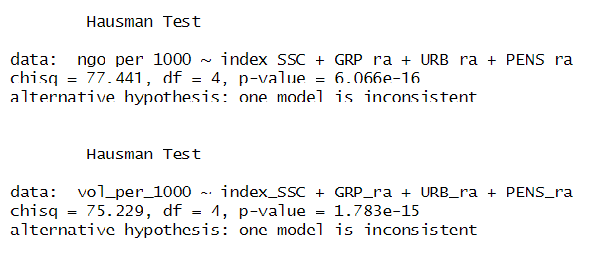
Appendix 2 “Descriptive statistics for the model of SSC’s impact on number of volunteers”
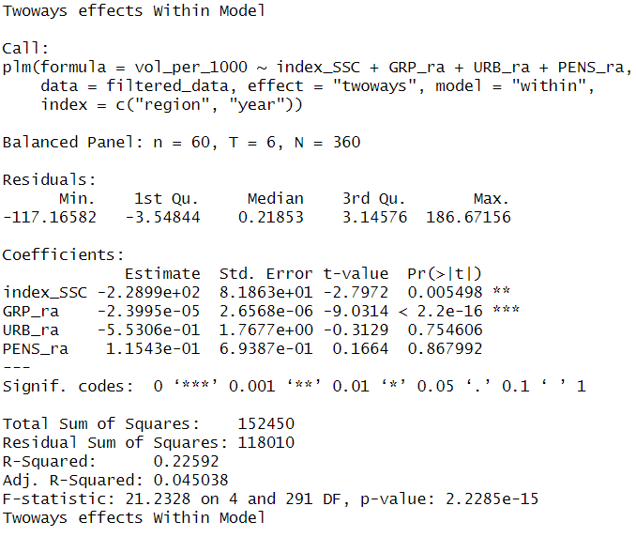

Appendix 3 “Descriptive statistics for the model of SSC’s impact on number of registered NGOs”
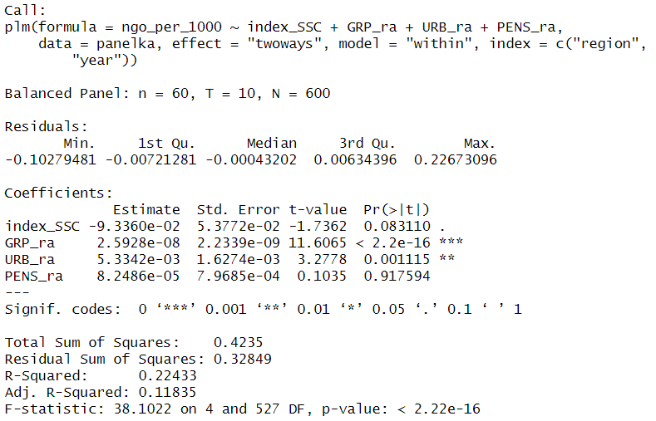
Appendix 4 “The first question from the survey about social trust”
Q1: Speaking generally, do you think that most people can be trusted or should you be very careful in dealing with people?
(1) | You can trust most of them
(2) | You have to be very careful when dealing with people.
Appendix 5 “The 23d question from the survey about satisfaction”
Q23: Now I'm going to name the various authorities, and tell me, how would you rate their work – as very good, pretty good, pretty bad, or very bad?
a) The governor of the region (territory, head of the republic) | 1 | 2 | 3 | 4
b) The mayor of your city (head of the district) | 1 | 2 | 3 | 4

Appendix 6 “The 26th question from the survey about civic participation before coding as dummy-variable”
 | Yes, I did it. | I haven't done it
Participation in a clean-up day, landscaping of the area or city where you live | 1 | 2
Signing of petitions, collective letters, and appeals, including on the Internet | 1 | 2
Participation in protest actions, pickets, demonstrations | 1 | 2
Write on the Internet – in blogs, on forums to attract people's attention | 1 | 2
Material donations for charity events | 1 | 2
Volunteering, including providing professional services  to solve a public problem, for a charity event | 1 | 2
Other forms of voluntary community service that you have participated in or could participate in to make life better around you? | 1 | 2

Appendix 7. The impact of incentives and resources on civic participation
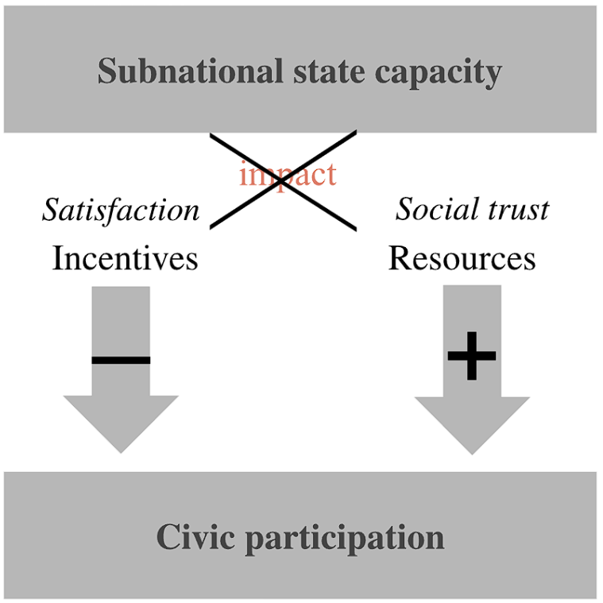

“Jefferson on Politics & Government: Good Government.” Accessed May 15, 2025. https://www.famguardian.org/Subjects/Politics/ThomasJefferson/jeff0650.htm.
Linz, Juan J., and Alfred Stepan. Problems of Democratic Transition and Consolidation. Johns Hopkins University Press, 1996. https://doi.org/10.56021/9780801851575. O’Donnell, Guillermo. “On the state, democratization and some conceptual problems: A Latin American view with glances at some post-communist countries”. World Development. 21(8) (1993): 1355-1369. Bäck, Hanna and Axel Hadenius. “Democracy and State Capacity: Exploring a J Shaped Relationship”. Governance: An International Journal of Policy, Administration and Institutions, 21(1) (2008): 1-24.
Fjelde, Hanne and Indra De Soysa. “Coercion, Co-optation, or Cooperation?: State Capacity and the Risk of Civil War, 1961-2004”. Conflict Management and Peace Science. 26(1) (2009): 5-25. Owen, C. (2020). Participatory authoritarianism: From bureaucratic transformation to civic participation in Russia and China. Review of International Studies, 46(4), 415-434. Owen, C., & Bindman, E. (2019). Civic participation in a hybrid regime: Limited pluralism in policymaking and delivery in contemporary Russia. Government and Opposition, 54(1), 98-120.
Ross, Cameron, Rostislav Turovsky, and Marina Sukhova. "Subnational State Capacity in Russia: The Implementation of the 2012 Presidential "May Decrees"." Demokratizatsiya: The Journal of Post-Soviet Democratization 30, no. 3 (2022): 263-282. https://muse.jhu.edu/article/860668.
Cnaan, R. A., & Park, S. (2016). The Multifaceted Nature of Civic Participation: A Literature Review. Voluntaristics Review, 1(1), 4 page. https://doi.org/10.1163/24054933-12340001
Levi, Margaret, and Laura Stoker. “Political Trust and Trustworthiness.” Annual Review of Political Science 3, no. Volume 3, 2000 (June 1, 2000): 475–507. https://doi.org/10.1146/annurev.polisci.3.1.475.
Rothstein, Bo & Stolle, Dietlind. “The State and Social Capital: An Institutional Theory of Generalized Trust.” Comparative Politics. 40. (2008): 441-459. https://doi.org/10.5129/001041508X12911362383354.
World Bank, The Role of Civic Engagement and Social Accountability in the Governance Equation, Social Development Notes, no. 75 (Washington, DC: World Bank, 2003), http://hdl.handle.net/10986/11313. M. A. Khan, "Civic Engagement in Policy Development," in The World Public Sector Report 2008: People Matter—Civic Engagement in Public Governance (New York: United Nations Department of Economic and Social Affairs, 2008), 50–74.
Weber, M. Bureaucracy. In Social theory re-wired (pp. 271-276). Routledge, 2023.
Lindvall, Johannes, and Jan Teorell. “State Capacity as Power: A Conceptual Framework.” State Capacity as Power: A Conceptual Framework, STANCE Working Paper Series, May 2016.
Bunce, Valerie. “Comparative Democratization. Big and Bounded Generalizations”. Comparative Political Studies, Vol. 33 No. 6/7 (2000): 703-734. Fukuyama, Francis. State-building: Governance and World Order in the 21st Century. Ithaca, NY: Cornell University Press, 2004. Kaufman, Daniel, Aart Kraay, Pablo Zoido. Governance Matters. World Bank Policy Research Working Paper No. 2196. (1994) Huber Evelyne, D. Rueschemeyer and J. D. Stephens. ‘The Impact of Economic Development on Democracy’, Journal of Economic Perspectives, 7, (1993) 71–85. Przeworski, Adam. Sustainable Democracy. Cambridge: Cambridge University Press. (1995) Mann, Michael. The Sources of Social Power: Volume 1: A History of Power from the Beginning to AD 1760. Vol. 1. Cambridge: Cambridge University Press, 1986. https://doi.org/10.1017/CBO9780511570896. Kurtz, Marcus J. and Andrew Schrank. 2012. “Capturing State Strength: Experimental and Economic Approaches”. Revista de Ciencia Política. 32(3): 613-621. Soifer, Hillel. "Measuring State Capacity in Contemporary Latin America". Revista de Ciencia Política. 32(3) (2012) : 585-598. Tilly, Charles. 1990. Coercion, Capital and the European States, A.D. 990-1990. Cambridge, Mass.: Basil Blackwell.
Theda Skocpol, States and Social Revolutions: A Comparative Analysis of France, Russia and China (Cambridge University Press, 1979, 16 p.
Tilly, C. The formation of national states in europe. Princeton: Princeton University (1975), 40.
Mann, Michael. The Sources of Social Power: Volume 1: A History of Power from the Beginning to AD 1760. Vol. 1. Cambridge: Cambridge University Press, 1986, 113 p. https://doi.org/10.1017/CBO9780511570896.
Putnam, Robert D., Robert Leonardi, and Raffaella Y. Nonetti. Making Democracy Work: Civic Traditions in Modern Italy. Princeton University Press, 1993. https://doi.org/10.2307/j.ctt7s8r7.
Giraudy, Agustina. “Conceptualizing State Strength: Moving Beyond Strong and Weak States”. Revista de Ciencia Política. (2012) 32(3): 599-611.
Hall, Peter. “Creative Cities and Economic Development.” Urban Studies 37, no. 4 (April 1, 2000): 639–49. https://doi.org/10.1080/00420980050003946.
Theda Skocpol, States and Social Revolutions: A Comparative Analysis of France, Russia and China (Cambridge University Press, 1979).
Kurtz, Marcus J. and Andrew Schrank. 2012. “Capturing State Strength: Experimental and Economic Approaches”. Revista de Ciencia Política. 32(3): 613-621. Soifer, Hillel. "Measuring State Capacity in Contemporary Latin America". Revista de Ciencia Política. 32(3) (2012) : 585-598. Tilly, Charles. Coercion, Capital, and European States, AD 990-1992. Cambridge, MA : Blackwell, 1992. http://archive.org/details/coercioncapitale0000till. Bunce, Valerie. “Comparative Democratization. Big and Bounded Generalizations”. Comparative Political Studies, Vol. 33 No. 6/7 (2000): 703-734. Fukuyama, Francis. State-building: Governance and World Order in the 21st Century. Ithaca, NY: Cornell University Press., 2004. Kaufman, Daniel, Aart Kraay, Pablo Zoido. Governance Matters. World Bank Policy Research Working Paper No. 2196., 1994. Huber Evelyne, D. Rueschemeyer and J. D. Stephens. ‘The Impact of Economic Development on Democracy’, Journal of Economic Perspectives, 7, (1993): 71–85. Przeworski, Adam. Sustainable Democracy. Cambridge: Cambridge University Press. (1995)
Ross, Cameron, Rostislav Turovsky, and Marina Sukhova. "Subnational State Capacity in Russia: The Implementation of the 2012 Presidential "May Decrees"." Demokratizatsiya: The Journal of Post-Soviet Democratization 30, no. 3 (2022): 263-282. https://muse.jhu.edu/article/860668.
White, David, and Marc Herzog. “Examining State Capacity in the Context of Electoral Authoritarianism, Regime Formation and Consolidation in Russia and Turkey.” In Exit from Democracy. Routledge, 2018. Ross, C., Turovsky, R., & Sukhova, M. “Subnational State Capacity in Russia: The Implementation of the 2012 Presidential" May Decrees". Demokratizatsiya: The Journal of Post-Soviet Democratization, 30(3), (2022): 263-282. Schenk, C. (2021). Producing state capacity through corruption: the case of immigration control in Russia. Post-Soviet Affairs, 37(4), 303-317. Smyth, Regina. “Building State Capacity from the Inside Out: Parties of Power and the Success of the Presidentals Reform Agenda in Russia.” Politics & Society 30, no. 4 (2002): 555–78.
Evans, P. and Rauch, J. E. . Bureaucracy and growth: A cross-national analysis of the effects of "Weberian" state structures on economic growth. American Sociological Review, 64(5) (1999): 748-765. Hamm, Patrick, and Lawrence King. “Post-Manichean Economics: Foreign Investment, State Capacity and Economic Development in Transition Economies.” Working Papers, Working Papers, 2010. https://ideas.repec.org//p/uma/periwp/wp227.html. Hamm, P., King, L. P., and Stuckler, D. (2012). Mass privatization, state capacity, and economic growth in post-communist countries. American Sociological Review, 77(2):295–324. Dincecco, Mark, and Gabriel Katz. “State Capacity and Long-Run Performance.” MPRA Paper, April 23, 2012. https://mpra.ub.uni-muenchen.de/38299/.
Evans, P. and Rauch, J. E. . Bureaucracy and growth: A cross-national analysis of the effects of "Weberian" state structures on economic growth. American Sociological Review, 64(5) (1999): 748-765.
Moon, Bruce E. and William J. Dixon.“Politics, the State, and Basic Human Needs: Cross-NationalStudy.” American Journal of Political Science. 29(4) (1985): 661–94. Roberts, C and Sherlock.“Bringing the Russian state back in: Explanations of the derailed transition to market democracy”. Comparative Politics. 31(4) (1999): 477-98.
Huntington, S. Political order in changing societies. New Haven, 1968. Fearon, J. D. and Laitin, D. D. Ethnicity, insurgency, and civil war. American Political Science Review, 97(01) (2003):75–90. Fearon, J. D. Primary commodity exports and civil war. Journal of Conflict Resolution, 49(4) (2005):483–507. DeRouen, K., Ferguson, M. J., Norton, S., Park, Y. H., Lea, J., and StreatBartlett, A. Civil war peace agreement implementation and state capacity. Journal of Peace Research, 47(3) (2010):333–346. DeRouen, K. R. and Sobek, D. The dynamics of civil war duration and outcome. Journal of Peace Research, 41(3) (2004):303–320. Fjelde, Hanne and Indra De Soysa. “Coercion, Co-optation, or Cooperation?: State Capacity and the Risk of Civil War, 1961-2004”. Conflict Management and Peace Science. 26(1) (2009): 5-25.
Fearon, J. D. and Laitin, D. D. Ethnicity, insurgency, and civil war. American Political Science Review, 97(01) (2003):75–90.
Linz, Juan and Alfred Stepan. Problems of Democratic Transition and Consolidation: Southern Europe, South America and Post-Communist Europe. Baltimore: Johns Hopkins University Press. (1996) O’Donnell, Guillermo. “On the state, democratization and some conceptual problems: A Latin American view with glances at some post-communist countries”. World Development. 21(8) (1993): 1355-1369. Bäck, Hanna and Axel Hadenius. “Democracy and State Capacity: Exploring a J Shaped Relationship”. Governance: An International Journal of Policy, Administration and Institutions, 21(1) (2008): 1-24.
Evans, P. B. Embedded Autonomy. Princeton University Press., 1995.
Weiss, L. The myth of the powerless state. Cornell Univ Pr., 1998.
DeRouen, K., Ferguson, M. J., Norton, S., Park, Y. H., Lea, J., and StreatBartlett, A. (2010). Civil war peace agreement implementation and state capacity. Journal of Peace Research, 47(3):333–346.
Parry, G., G. Moyser and N. Day. 1992. Political Participation and Democracy in Britain.Cambridge: Cambridge University Press. Hardin, Russell. 1982. Collective Action. Baltimoreand London: Johms Hopkins University Press. Ekman, Joakim, and Erik Amnå. “Political Participation and Civic Engagement: Towards a New Typology.” Human Affairs 22, no. 3 (July 1, 2012): 283–300. https://doi.org/10.2478/s13374-012-0024-1. Pod"iachev, K. V. "Osnovnye formy grazhdanskogo uchastiya v usloviyakh sovremennoy Rossii." Nauchnaya elektronnaya biblioteka Grazhdanskoe obshchestvo v Rossii, 2-3. Moscow, 2013. J. V. Deth, J. R. Montero and Anders Westholm. "Citizenship and involvement in European Democracies : A Comparative Analysis." (2007). https://doi.org/10.4324/9780203965757
Ekman, Joakim, and Erik Amnå. “Political Participation and Civic Engagement: Towards a New Typology.” Human Affairs 22, no. 3 (July 1, 2012): 283–300. https://doi.org/10.2478/s13374-012-0024-1. M. Barrett and I. brunton-smith. "Political and Civic Engagement and Participation: Towards an Integrative Perspective." Journal of Civil Society, 10 (2014): 28 - 5. https://doi.org/10.1080/17448689.2013.871911. Yerkebulan Sairambay. "Reconceptualising political participation." Human Affairs, 30 (2020): 120 - 127. https://doi.org/10.1515/humaff-2020-0011
Ekman, Joakim, and Erik Amnå. “Political Participation and Civic Engagement: Towards a New Typology.” Human Affairs 22, no. 3 (July 1, 2012): 283–300. https://doi.org/10.2478/s13374-012-0024-1.
Ibid.
Amanda McBride. "Civic Engagement, Older Adults, and Inclusion." , 30 (2006): 66. Amanda McBride, M. Sherraden and Suzanne Pritzker. "Civic Engagement Among Low‐Income and Low‐Wealth Families: In Their Words." Family Relations, 55 (2006): 152-162. https://doi.org/10.1111/J.1741-3729.2006.00366.X
Stephanie Moore, Elan C. Hope, Andria B. Eisman and M. Zimmerman. "Predictors Of Civic Engagement Among Highly Involved Young Adults: Exploring The Relationship Between Agency And Systems Worldview." Journal of Community Psychology, 44 (2016): 888-903. https://doi.org/10.1002/JCOP.21815
Amanda McBride, M. Sherraden and Suzanne Pritzker. "Civic Engagement Among Low‐Income and Low‐Wealth Families: In Their Words." Family Relations, 55 (2006): 152-162. https://doi.org/10.1111/J.1741-3729.2006.00366.X
Bergson, Abram. Review of Review of An Economic Theory of Democracy, by Anthony Downs. The American Economic Review 48, no. 3 (1958): 437–40. Harper & Brothers. Finch, W. Holmes, Jocelyn E. Bolin and Ken Kelley. 2014. Multilevel Modeling Using R. Boca Raton, Fl: CRC Press.
Cnaan, R. A., & Park, S. (2016). The Multifaceted Nature of Civic Participation: A Literature Review. Voluntaristics Review, 1(1), 4 page. https://doi.org/10.1163/24054933-12340001
B. Checkoway and Adriana Aldana. "Four forms of youth civic engagement for diverse democracy." Children and Youth Services Review, 35 (2013): 1894-1899. https://doi.org/10.1016/J.CHILDYOUTH.2013.09.005
Zhou, M. (2012). Participation in international human rights NGOs: The effect of democracy and state capacity. Social Science Research, 41(5), 1254-1274. Somuano, F., & Nieto, F. (2017). Subnational State Capacity and Civic and Political Participation in Mexico. Cuthill, M., & Fien, J. (2005). Capacity building: Facilitating citizen participation in local governance. Australian journal of public administration, 64(4).
Michael Cuthill and John Francis Fien. "Capacity building: Facilitating citizen participation in local governance." Australian Journal of Public Administration, 64 (2005): 63-80. https://doi.org/10.1111/J.1467-8500.2005.00465A.X
Salmenniemi, S. (2010). Struggling for citizenship: Civic participation and the state in Russia. Demokratizatsiya, 18(4), 309. Owen, C. “Participatory Authoritarianism: From Bureaucratic Transformation to Civic Participation in Russia and China.” ResearchGate, 2024. https://doi.org/10.1017/S0260210520000248. Owen, C., & Bindman, E. “Civic participation in a hybrid regime: Limited pluralism in policymaking and delivery in contemporary Russia. Government and Opposition”, 54(1) (2019). 98-120. https://doi.org/10.1017/GOV.2017.13.
Min Zhou. "Participation in international human rights NGOs: The effect of democracy and state capacity.." Social science research, 41 5 (2012): 1254-74 . https://doi.org/10.1016/J.SSRESEARCH.2012.03.011
Linz, Juan and Alfred Stepan. Problems of Democratic Transition and Consolidation: Southern Europe, South America and Post-Communist Europe. Baltimore: Johns Hopkins University Press. (1996) O’Donnell, Guillermo. “On the state, democratization and some conceptual problems: A Latin American view with glances at some post-communist countries”. World Development. 21(8) (1993): 1355-1369. Bäck, Hanna and Axel Hadenius. “Democracy and State Capacity: Exploring a J Shaped Relationship”. Governance: An International Journal of Policy, Administration and Institutions, 21(1) (2008): 1-24.
Somuano, F., & Nieto, F. (2017). Subnational State Capacity and Civic and Political Participation in Mexico.
“Democracy Index 2017.” Accessed February 17, 2025. https://www.eiu.com/public/topical_report.aspx?campaignid=DemocracyIndex2017.
Soifer, Hillel, and Matthias vom Hau. “Unpacking the Strength of the State: The Utility of State Infrastructural Power.” Studies in Comparative International Development 43, no. 3 (December 1, 2008): 219–30. https://doi.org/10.1007/s12116-008-9030-z.
Hanson J.K. (2018) “State Capacity and the Resilience of Electoral Authoritarianism: Conceptualizing and Measuring the Institutional Underpinnings of Autocratic Power” // International Political Science Review, vol. 39, no. 1: 17—32.
Centeno, Miguel Angel, Atul Kohli, Deborah J. Yashar, and Dinsha Mistree. “Unpacking States in the Developing World: Capacity, Performance, and Politics.” Chapter. In States in the Developing World, edited by Miguel A. Centeno, Atul Kohli, and Deborah J. Yashar, 1–32. Cambridge: Cambridge University Press, 2017.
Campbell, Jesse W. “Public Participation and Trust in Government: Results From a Vignette Experiment.” Journal of Policy Studies 38, no. 2 (2023): 23–31. https://doi.org/10.52372/jps38203.
Addison, Helen. “Is Administrative Capacity a Useful Concept ? Review of the Application , Meaning and Observation of Administrative Capacity in Political Science Literature.” (2010).
Yale Journal of International Affairs. “State Capacity as a Conceptual Variable,” July 20, 2010. https://www.yalejournal.org/publications/state-capacity-as-a-conceptual-variable.
Haque, M. Shamsul, M. Ramesh, Jose A. Puppim de Oliveira, and Alexandre de Avila Gomide. “Building Administrative Capacity for Development: Limits and Prospects.” International Review of Administrative Sciences 87, no. 2 (June 1, 2021): 211–19. https://doi.org/10.1177/00208523211002605.
Gargan, John J. 1981. "Consideration of Local Government Capacity." Public Administration Review 41 (6):649-58.
Bowman, Ann O'M., and Richard C. Kearney. 1988. "Dimensions of State Government Capability." The Western Political Quarterly 41 (2):346.
May, Peter J. 2003. "Policy Design and Implementation." In Handbook of Public Administration, ed. B. G. Peters and J. Pierre. London: Sage Publications.
Somuano, F., & Nieto, F. (2017). Subnational State Capacity and Civic and Political Participation in Mexico.
Goggin, Malcolm, Ann Bowman, James Leste, and Laurence O'Toole Jr. 1990. Implementation Theory and Practice: Toward a Third Generation. New York: Harper Collins, 38 p.
Ross, Cameron, Rostislav Turovsky, and Marina Sukhova. "Subnational State Capacity in Russia: The Implementation of the 2012 Presidential "May Decrees"." Demokratizatsiya: The Journal of Post-Soviet Democratization 30, no. 3 (2022): 263-282. https://muse.jhu.edu/article/860668.
Jaros K. (2016) “Rethinking Subnational Government Capacity in China” // Journal of Chinese Governance, vol. 1, no. 4: 633—653.
Social Policy and State Capacity from a Sub-National Perspective (pp. 895–912). (2023). Oxford University Press eBooks. https://doi.org/10.1093/oxfordhb/9780190916329.013.60
Gel’man, V. (2010). The dynamics of subnational authoritarianism: (Russia in comparative perspective). Russian Politics and Law, 48(2), 7–26. https://doi.org/10.2753/RUP1061-1940480201
Moses, J. C. (2015). Putin and Russian Subnational Politics in 2014. Demokratizatsiya: The Journal of Post-Soviet Democratization, 23(2), 181–203. https://www.questia.com/library/journal/1P3-3759949571/putin-and-russian-subnational-politics-in-2014
Ibid.
Duvanova, D. (2023). Bureaucratic Discretion and State Capacity in Russian Regions (pp. 141–172). Oxford University Press. https://doi.org/10.1093/oso/9780197697764.003.0005
Sukhova, M. (2023). Subnational State Capacity and Pro-Government Voting in Russia. Полития, 109(2), 113–129. https://doi.org/10.30570/2078-5089-2023-109-2-113-129
Ross, Cameron, Rostislav Turovsky, and Marina Sukhova. “The COVID-19 Pandemic as a Test of Russia’s Subnational State Capacity.” Demokratizatsiya: The Journal of Post-Soviet Democratization 31, no. 4 (2023): 461–84.
TASS. "Istoriya s milliardom nalichnymi: za chto osudili eks-gubernatora Khoroshavina - TASS." Accessed March 31, 2025. https://tass.ru/proisshestviya/4566459. 2025.
Malafaia, C., Luhtakallio, E., Menezes, I., & Neves, T. (2018). Being civic while disavowing politics: An ethnography of a youth NGO in Portugal. Current Sociology, 19(5). https://doi.org/10.1177/0011392117704243
Jeong, H. O. (2013). From Civic Participation to Political Participation. Voluntas, 24(4), 1138–1158. https://doi.org/10.1007/S11266-012-9316-7
Verba, Sidney, Kay Lehman Schlozman, and Henry E. Brady. Voice and Equality: Civic Voluntarism in American Politics. Harvard University Press, 1995. https://doi.org/10.2307/j.ctv1pnc1k7.
Noh, Y., Public Opinion and Women’s Rights in Autocracies, Politics & Gender, pp. 1–5, March 16, 2023. DOI: 10.1017/s1743923x22000514 Tsai, L. L. and Xu, Y., Outspoken Insiders: Political Connections and Citizen Participation in Authoritarian China, Political Behavior, vol. 40, no. 3, pp. 629–57, from https://link.springer.com/article/10.1007/s11109-017-9416-6, September 1, 2018. DOI: 10.1007/S11109-017-9416-6
Owen, C. “Participatory Authoritarianism: From Bureaucratic Transformation to Civic Participation in Russia and China.” ResearchGate, 2024. https://doi.org/10.1017/S0260210520000248. Owen, C., & Bindman, E. “Civic participation in a hybrid regime: Limited pluralism in policymaking and delivery in contemporary Russia. Government and Opposition”, 54(1) (2019). 98-120. https://doi.org/10.1017/GOV.2017.13. Salmenniemi, S. (2010). Struggling for citizenship: Civic participation and the state in Russia. Demokratizatsiya, 18(4), 309.
Izvestiia. "Rossiia sosredotachivatesia - vyzovy, na kotorye my dolzhny otvetit' | Stat'i | Izvestiia." Accessed April 4, 2025. https://iz.ru/news/511884. 2025.
“Konsul'tantPlus. "Federal'nyi zakon 'Ob osnovakh obshehestvennogo kontrolia v Rossiiskoi Federatsii' ot 21.07.2014 N 212-FZ (poslednia radakisia)." Accessed April 4, 2025. https://www.consultant.ru/document/cons_doc_LAW_165809/. 2025.
Owen, C., & Bindman, E. “Civic participation in a hybrid regime: Limited pluralism in policymaking and delivery in contemporary Russia. Government and Opposition”, 54(1) (2019). 98-120. https://doi.org/10.1017/GOV.2017.13.
Ibid.
Ibid Linz, J. (2000) Totalitarian and Authoritarian Regimes. Boulder, CA: Lynne Rienner Publishers Ltd.
Mersianova, Irina Vladimirova. "Grazhdanskoe uchastie vo vremia pandemii COVID-19." Sotsiodigger 2, no. 3 (8) (2021): 16-26. https://cvberleninka.ru/article/n/grazhdanskoe-uchastie-vo-vremya-pandemii-covid-19. 2021. RBK. "VSHe soobshchila o roste glubinnoi grazhdanskoi aktivnosti rossiian." December 7, 2020. https://www.rbc.ru/rbcfreenews/Sfcec52b9a794796ff11ca6. 2020.
"Konsul'tantPlys. 'UK RF Stat'ia 280.3. Publichnye deistviia, napravlennye na diskreditatsiiu ispol'zovanlia Vooruzhennykh Sil Rossiiskoi Federatsii v tseliakh zashchity interesov Rossiiskoi Federatsii i ee grazhdan, podderzhanlia mezhdunarodnogo mira i bezopasnosti, ispolneniia..." Accessed April 4, 2025. https://www.consultant.ru/document/cons_doc_LAW_10699/laa9268c7d3bd57bcbd46a3016641c5af64b9c87/. 2025.
"Reestr SO NKO, rabotaiushchikh s uchastnikami SVO." Accessed April 4, 2025. https://admtyumen.ru/ogv_ru/society/social_policy/article.htm?id=12073283@emsArticle. 2025.
Pod"iachev, K. V. 2013. "Osnovnye formy grazhdanskogo uchastiia v usloviiakh sovremennoi Rossii" [Основные формы гражданского участия в условиях современной России]. In Grazhdanskoe obshchestvo v Rossii [Гражданское общество в России], 2–3. Moscow.
Omoto, Allen M., And Mark Snyder. “Considerations of Community: The Context and Process of Volunteerism.” American Behavioral Scientist 45, no. 5 (January 1, 2002): 846–67. https://doi.org/10.1177/0002764202045005007.
Mercer, Claire. “NGOs, Civil Society and Democratization: A Critical Review of the Literature.” Progress in Development Studies, January 1, 2002. https://doi.org/10.1191/1464993402ps027ra.
Levi, Margaret, and Laura Stoker. “Political Trust and Trustworthiness.” Annual Review of Political Science 3, no. Volume 3, 2000 (June 1, 2000): 475–507. https://doi.org/10.1146/annurev.polisci.3.1.475.
Häggblom, E. (2024). The Trade-Off Between Political Trust and Political Participation. Political Studies Review. https://doi.org/10.1177/14789299241304611
Lee, S.-W., Liu, W.-L., & Nah, S. (2022). Advancing Communication Infrastructure Theory: The Moderating Roles of Citizen Journalism Practice and Political Trust on Online Civic Participation. Mass Communication and Society, 1–25. https://doi.org/10.1080/15205436.2022.2093750
Schiffman, Leon, Shawn T. Thelen, and Elaine Sherman. “Interpersonal and Political Trust: Modeling Levels of Citizens’ Trust.” Edited by Phil Harris and Andrew Lock. European Journal of Marketing 44, no. 3/4 (January 1, 2010): 369–81. https://doi.org/10.1108/03090561011020471. Rothstein, Bo & Stolle, Dietlind. (2008). The State and Social Capital: An Institutional Theory of Generalized Trust. Comparative Politics. 40. 441-459. https://doi.org/10.5129/001041508X12911362383354.
D. Meng and E. Berezina. "The Role of Personality and Self-Motivation in Political (Dis)Engagement." Makara Hubs-Asia, 24 (2020): 87. https://doi.org/10.7454/hubs.asia.2070220.
"Regional statistics." Accessed May 15, 2025. https://rosstat.gov.ru/regional_statistics. The Ministry of Justice of the Russian Federation. "Register of non-governmental organizations" Accessed May 15, 2025. https://minjust.gov.ru/ru/pages/reestr-nekommercheskih-organizacji/.
Vidyasova, Liudmila Aleksandrovna, Irina Andreevna Grigorieva, and Aitalina Sergeevna Krivoshapkina. "Kar'ernye ozhidamia pozhilykh v Rossii: na osnove analiza bazy reziume s portala Rostruda 'Rabota Rossii'." Monitoring obshehestvennogo mnemia: ekonomicheskie i sozial'nye peremeny, no. 1 (March 4, 2024): 26-47. https://doi.org/10.14515/monitoring.2024.1.2430. 2024. OVD-Info. 'Eydzhizm i vozrastnaya diskriminatsiya v kontekste svobody sobraniy v Rossii.' Accessed April 18, 2025. https://reports.ovd.info/eydzhizm-i-vozrastnaya-diskriminatsiya-v-kontekste-svobody-sobraniy-v-rossii."
Almakaeva, A., Andreenkova, A., Klimova, A., Soboleva, N., & Ponarin, E. (2019). Values in the Russian Regions, LCSR Regional Survey. Moscow: Higher School of Economics.
The President of Russia. "Decree on the National Development Goals of the Russian Federation for the period up to 2030 and for the future up to 2036" May 9, 2024. https://kremlin.ru/events/president/news/73986.
"Regional statistics." Accessed May 15, 2025. https://rosstat.gov.ru/regional_statistics.
Benevolenski, Vladimir B., and Stefan Toepler. “Modernising Social Service Delivery in Russia: Evolving Government Support for Non-Profit Organisations.” Development in Practice, January 2, 2017. https://www.tandfonline.com/doi/abs/10.1080/09614524.2017.1259392.
Rothstein, Bo & Stolle, Dietlind. (2008). The State and Social Capital: An Institutional Theory of Generalized Trust. Comparative Politics. 40. 441-459. https://doi.org/10.5129/001041508X12911362383354.

